Servlet Background:
From Jeff Conner, ASU Active Tectonics

(Excerpt from Sun’s Servlet Site)

Servlets are the Java platform technology of choice for extending and enhancing Web servers. Servlets provide a component-based, platform-independent method for building Web-based applications, without the performance limitations of CGI programs. And unlike proprietary server extension mechanisms (such as the Netscape Server API or Apache modules), Servlets are server- and platform-independent. This leaves you free to select a "best of breed" strategy for your servers, platforms, and tools.
Servlets have access to the entire family of Java APIs, including the JDBC API to access enterprise databases. Servlets can also access a library of HTTP-specific calls and receive all the benefits of the mature Java language, including portability, performance, reusability, and crash protection.

In a nutshell, Servlets are web-based means of presenting information using the Java language. They have their own scripting language (but is not JavaScript). The advantage with Servlets is that developers can create java programs to process information and present the results on the web dynamically.

Our Implementation Scheme:

I use Servlets as a front-end to the Java programs that I write to implement the scripts that drive the programs that process our data. Here is a quick look at the scheme:

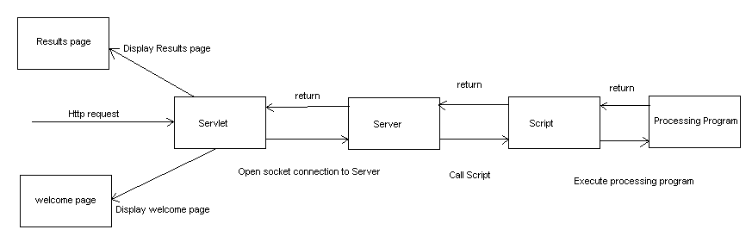

When I say Servlet I am actually referring to a collection of Servlets. The Servlet is more of a manager that sends information to various JSPs (Java Servlet Page) to display information. As an analogy, try to think of the Servlet as a director and JSPs as actors. A director tells the actors when to be on stage and in what role they play in each scene. The Servlet receives information and based upon that information displays the appropriate JSP to correctly relay that information. So when you are viewing the Servlet from the web you are actually looking at a JSP page that the Servlet chose to show you based upon the information that was sent to it in the previous request.

When the Servlet has finished collecting information and is ready to pass off a request to the Java Server, which in turn will call the script to activate whatever program we are using to process data (i.e. GRASS, IDL), it creates a transaction, which is like a container for the data, and opens a socket connection to the server via a client program, also written in Java. The Servlet then waits for a response from the server that its request has been completed. The Servlet assumes that the data was processed correctly and builds a results page (also a JSP) with the appropriate information (such as path, filename, etc.) and presents that page to the user for viewing.

More on Sockets:

Sockets provide a peer-to-peer communications protocol over TCP/IP. Sockets are a standard for TCP/IP communication over a network. A web server or an FTP server would be two examples of a socket-implemented server. They are supported by all operating systems. They consist of two parts: an IP address and a port number. Java can utilize this technology to pass objects through the socket from one program to another. This allows information sharing between programs on different machines.

Socket relation to Servlets:

Servlets have certain security measures in place; most importantly they do not allow direct writing of local files. In order to write to files locally in our Servlets I create a server that accepts a socket connection from a client program that can be used by our Servlets to send information that needs to be written to a local file. To use another analogy think of using sockets as calling someone up on the phone. The number you dial is analogous to the IP/port combination. Imagine now that you asked the person on the other line to do something for you. You wait on the phone until they tell you that they’re done and you hang up assuming that what you asked for was completed. It works similar in the implementation I have used for our Servlet projects.

Flow Control:

Another reason to use the Client-Server method in our process is for flow control. When requests come into the Server from the Servlet, they are placed in a queue. I use a FIFO (first in first out) scheme to run the jobs that are in the queue. When one job is running all other requests are frozen until the job that is running completes. The request that came in after the current one is the next to run and so on. Although perhaps not the most efficient method this ensures that every job will be run and that no job gets priority over another. Once a job has completed the Servlet is then notified of completion and it completes its job.

