ArcGIS 8.3 Installation
By Jeff Conner

Step 1: Obtain License File:

- Locate the name of the computer you are installing ArcGIS on. Under windows 2000 right click on My Computer and select the Network Identification tab. Write down the entry to the left of “full computer name”. This is your Computer Name
- To find the computer name in XP See the notes on the last page.
- Go to the myesri website (http://www.myesri.com/sitelogin.htm is the site as of the creation date of this document 7-13-04). The user name (as of 7-13-04) is 102282SITE1 and the password is TIMESHOW. Make sure to maintain any caps in both the username and password.
- After logging in click on “Create keycodes for ArcGIS”
- Leave the contact name as is
- Select the proper operating system (This tutorial reflects windows installation so select NT if using this tutorial as a reference).
- The Platform will be Windows NT – INTEL
- Enter the model name of you computer
- Enter the hostname obtained in the first step, which is your computer name.
- Enter your ESRI sentinel key, which can be found on the dongle obtained from CAC.
- The Software version is 8.x
- Click on go
- On the next screen place a 1 in every text box to the left of the expiration date.
- When finished click on finish
- On the next screen click on “E-mail keycode to” and place your e-mail address in the field. The license file will be mailed to this location so make sure it is valid.
- Click on go when finished
- When you receive the license file in your e-mail download it to the computer on which you are installing ArcGIS. This will be used in a later step.
- Done with license acquisition.

Step 2: Installing the License Manager:

- Insert the ArcGIS 8.x Desktop CD into the CDROM drive.
- When prompted select the Install License Manager option and click on next
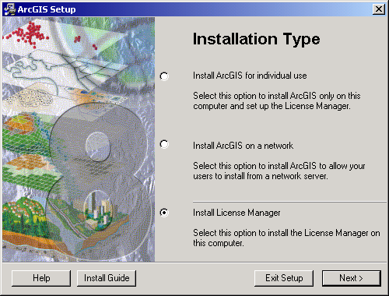
- Click next on the welcome screen
- Make sure “I received the license file by e-mail and have saved it to disk” is selected ad click on browse. Browse to the license file that you downloaded from your e-mail, select it and click on open.
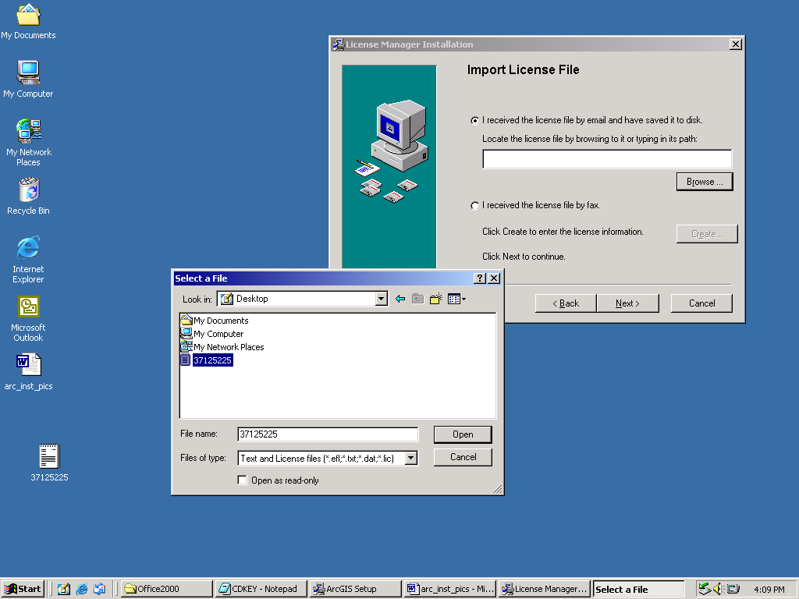
- With the license file entered click on next and then next again on the license summary screen and finally install on the Installation Summary screen.
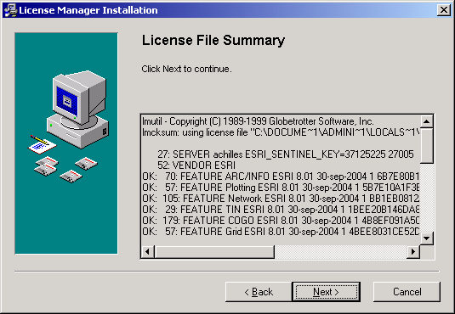
- Click on finish when the installation completes
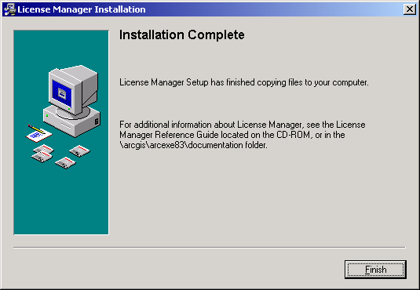
- Reboot the computer and insert the sentry key onto either the parallel port or a free USB port depending on what kind of key you have.
- Log in back with the account that you installed the license manager with.
- If the computer says that ESRI needs the sentinel key and you have a USB key remove the key and reinsert it.
- Verify that the license manager has been started. Go to the services menu (start→ settings → control panel → Administrative tools → Services) and check to see if the ESRI License manager is started. If it hasn’t started try to start it by clicking on the play icon in the upper left of the window. If it still doesn’t start contact the Technical support person.
- Assuming the License manager started this phase is complete

Step 3: Installing ArcGIS software:

- Double-click on the cdrom drive to start the installation. If it just opens up the cdrom drive then double click on Setup. You could also eject and re-insert the cd

- Make sure “Install ArcGIS for individual use” is selected and click on next.
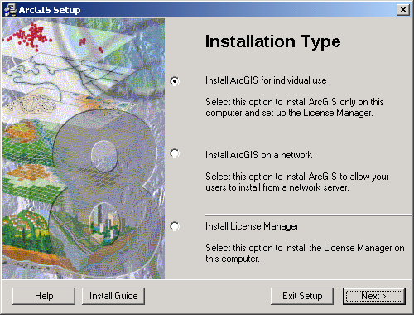
- It should say “An operational license manager has been found…” If you get anything but the following screen you need to verify that the ESRI license manager started properly. Click on yes to use this license manager.
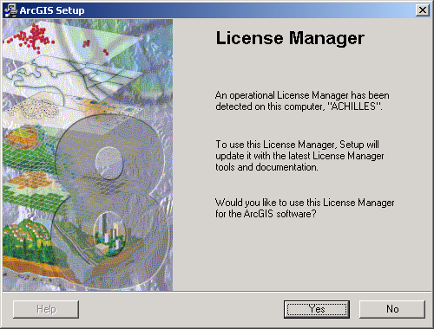
- On the next screen click on “update Microsoft system files”.
- When ArcGIS has finished updating files it will prompt you to reboot. Click restart computer to reboot.
- You will be prompted with a reminder to log in as the user who is installing the program. Click on ok on this screen to reboot.
- When the system comes back up log back in as the user who is installing everything so far. Make sure the ESRI license manager started by checking in services once again.
- The ArcGIS installer will automatically come up with the following screen. Click on next to continue the installation.
- On the License agreement screen click on “I accept…” and click on next.
- On the next screen make sure ArcInfo is selected and click on next.
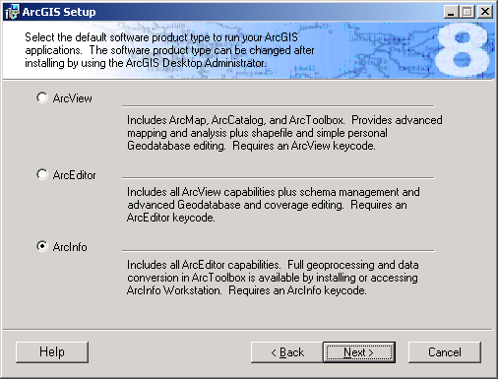
- Select complete and click on next.
- Select C:\arcgis or whatever drive has enough free space.
- Click on next to start the installation.
- You will be presented with this screen when the installation has completed. Click on finish to complete the installation.
- Click on the ArcInfo Workstation screen that comes up next. We will be installing this shortly.
- You can choose to install the additional components if you like. They will not be covered in this tutorial however.
- Test that ArcGIS runs my launching ArcMap from the start menu in the ArcGIS program group. Verify that you are able to create a blank map. If you can it means the license manager is functioning properly.
- End of this section

Step 4: Installing ArcInfo Workstation:

- Before doing this step make sure that the previous step succeeded otherwise you will likely have to uninstall both Desktop and Workstation to fix any license issues.
- Insert the ArcInfo Workstation 8.3 disc 1 into the CDROM drive.
- Make sure “Install ArcGIS for individual use” is selected and click on next.
- You should again see the License manager screen and it should say “An operational License Manager has been detected…” If you don’t see this screen there is a problem with the ESRI license manager and it will have to be fixed before continuing the installation.
- Click “Yes” on the License manager screen.
- Click “Next” on the welcome screen.
- Click on “I accept…” on the License Agreement screen and then “Next”
- Make sure “Complete” is selected and click on “Next”
- Select an installation path and click on “Next”. The default path is usually best unless you have disk space issues.
- Select a workspace directory (the default is usually best) and click on “Next”
- Click “Next” on the Start Installation screen to begin the installation.
- Insert Disc 2 when prompted and press ok
- Click on Finish when prompted.
- To verify the installation was successful open a dos shell (start→run; type “cmd”)
- Type “arc” and press enter
- You should get a prompt like on the following screen. If you get an error it is probably the ESRI license manager. Correct the problem and try again. Otherwise…
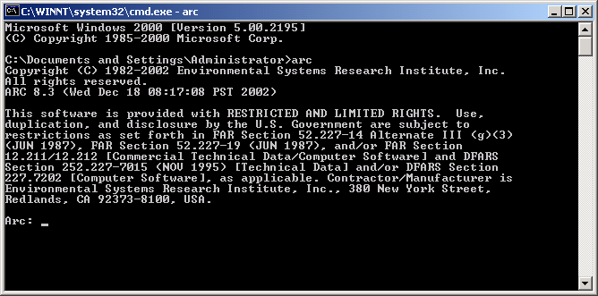
- This step and the tutorial are completed.

Notes:

- If, upon booting up, you are unable to use ArcMap check to see if the ESRI license manager started. Sometimes it fails and needs to be manually started.

Changing the Computer Name in Windows XP:

- Click on the start menu, find “My Computer” and right-click on it and select properties.
- Click on the Network Identification Tab.
- Click on properties
- Change the computer name in the box below the “Computer Name” label.
- Click on the “OK” button.
- Click on the “OK” button when prompted.
- Click “OK” on the properties windows and then restart button to complete the process.

