Kartographische Bausteine
Band 28
Dresden 2004

Proceedings of the 7th

INTERNATIONAL SYMPOSIUM
ON
HIGH-MOUNTAIN REMOTE SENSING
CARTOGRAPHY
(HMRSC VII)

held in
Bishkek, KYRGYZSTAN
July 15 – 26 2002




Editor:
Manfred F. Buchroithner, Dresden

Desktop Publishing:
Robert Hecht

Printed by:
Dresden University of Technology
Institute for Cartography (KTE)

High Mountain Remote Sensing Cartography VII (HMRSC VII)
Ed. by Manfred F. Buchroithner, Institute for Cartography of the Dresden University of Technology, 2004. Kartographische Bausteine, Band 23, Dresden 2004.
ISBN: 3 - 86005 - 435 - X

© Institute for Cartography of the Dresden University of Technology
Dresden 2004
ISBN: 3 - 86005 - 435 - X

Andrey M. Korjenkov, Vitaly A. Kovalenko, Salavat F. Usmanov

Long-Term Preservation of Paleoseismic Deformations as a Tool for Revealing Traces of Ancient Seismic Catastrophes (On Example of the Chon-Kemin Valley, Kyrghyzstan)

1 Introduction - Geological and Tectonic Background
Seismogenic zones for most parts of the world are considered in the seismotectonic literature as being conservative in the sense that they represent areas of long term seismic activity, encompassing paleo-, historic and modern earthquakes (Gubin, 1960; Wallace, 1970; Trifonov, 1971, 1983; Savage and Burford, 1973; Nikonov, 1977; Ai et al., 1987; Carton et al., 1987; Bollinger and Costain, 1988; Morner et al., 1989; and many others). This concept is examined for one of the most well-known seismogenic zones of the northern Tien Shan, The Chilik-Kemin Seismic Zone (CKSZ), roughly situated at 76-77°W and 42-43°N. Historic earthquakes recorded in the region include the 1887 Chilik (M = 8.4) and 1911 Kebin (M = 8.2) earthquakes.
Seismic deformations formed in result of these and more ancient earthquakes were studied by many investigators (Bogdanovich et al., 1914; Goryachev, 1959; Kuchay, 1972; Tokombaev, 1963; Utirov, 1978, Korjenkov, 1995, 1998; Chedia and Korjenkov, 1997, Korjenkov and Chedia, 1999). There are also seismic deformations of different age in other seismically active zones of the Tien Shan (Leonov, 1965; Kuchay, 1971; Korjenkov and Chedia, 1986, Omuraliev and Charimov, 1990; Korjenkov and Charimov, 1993, Korjenkov, 2000 and others).
Chilik-Kemin Seismogenic Zone (Utirov, 1978; Experience…, 1975) extends sub-latitudinally for more that 200 km along the faults following the Caledonian zone of folding of the same time. The CKSZ is bounded to the north by the Muyunkum-Narat Median Massif and to the south by the Issyk-Kyl Median Massif. During the Cenozoic the CKSZ was a depression of a ramp structure (Chedia, 1986, 1990, Korjenkov, 1988, 1995, 1998; Chedia and Korjenkov,1997; Korjenkov and Chedia, 1999) and not the rift one, as it was attributed by some researchers (Patalakha and Chabdarov, 1976; Nesmeyanov and Barkhatov, 1982).
The western part of the CKSZ was studied for evidence of paleoseismic activity, including Novorossyika depression and the upstream portion of the Chonkemin River to the Dzhyndysu River (Fig. 1) (Chedia and Korjenkov, 1997; Korjenkov and Chedia, 1999). Here, traces of the Kebin earthquake of 1911, such as cracks and small landslides, are significantly modified by exogenic processes, however traces of paleoearthquakes are still evident and have not been fully studied. As an attempt to fill this gap, the authors used geologic and geomorphologic methods for estimating ages of deformation in this area, including the use of existing, relative correlations of geomorphologic features and Quaternary deposits (Kachaganov, 1975; Chedia, 1986).

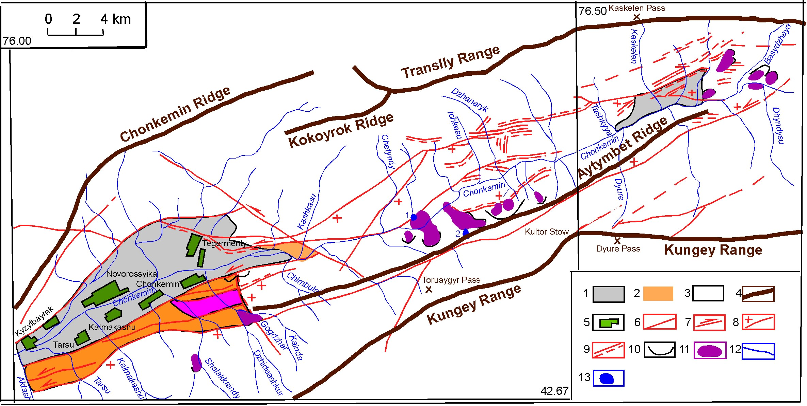

Fig. 1: Western part of the Chilik-Kemin Seismic Zone (Modified after Chedia and Korjenkov, 1997).
1 - Quaternary deposits;
2 – Paleogene-Neogene deposits partly covered by Quaternary alluvial and fluvio-glacial deposits;
3 – Premesozoic rocks;
4 – watersheds of ranges;
5 – settlements;
6 – Neotectonic faults,
7 – strike-slip faults,
8 – thrusts (+ is hanging wall);
9 – fault scarps and upslope facing scarp on the slopes;
10 – scars of rock avalanches and landslides,
11 - bodies of rock avalanches and landslides;
12 – rivers,
13 – lakes (1 – Dhashilkyol, 2 – Kyolkogur).

The Chilik-Kemin graben-ramp is bounded to the south by the Southern-Kemin Boundary Fault, along which the Kungey-Alatoo Range is thrusted to the north. Vertical displacement in the region of the Novorossyika depression is 1.5 km. This depression is very asymmetric. The southernmost lowered part is covered by red-color deposits of the Kokturpak (K2 - Pg3 kk) and Kyrgyz (Pg3 - N1 kr) Formations. Deposits of the Kyrgyz Fm. one can observe in socles of the Late Pleistocene terraces in the near-mouth part of right tributary of Kashkasu River. Higher up the section there are ash-color deposits of Miocene-Pliocene of significant thickness. Upper parts of a molassa complex are found only in the northwest part of the depression.
The northern boundary of the ramp-graben coincids with small-amplitude neotectonic thrusts and the Central-Kemin Fault, along which on the west there were observed the left-lateral strike-slip faults (Fig. 2), and on the east – right-lateral strike-slip movements.

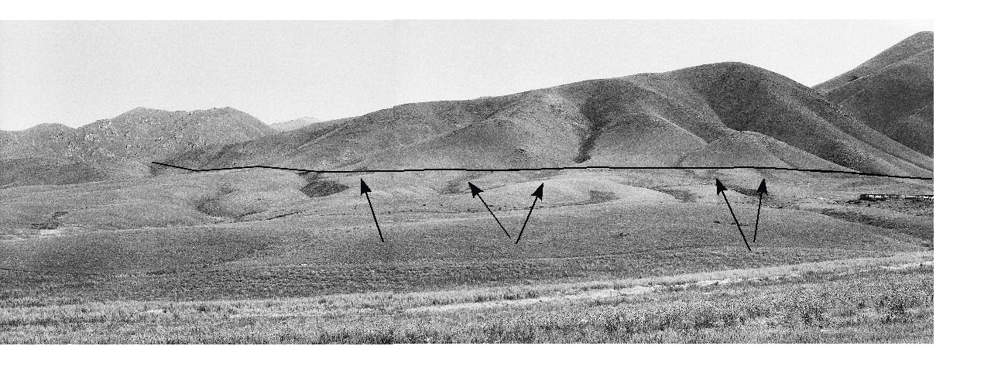
Fig. 2: Photograph of the strike-slip fault (shown by a line) in the eastern termination of the Novorossyika depression. Arrows show beheaded gullies. Photo of 1991 by A. Korjenkov.

2 Description of seismic deformations

Seismic deformations in the east of the Novorossyika Depression
The Novorossyika Depression is cut in the east by two diagonal, oblique fault near the mouth of the Rashkasu river and in the right bank of the Ortokayindy River (Gogzdar fault). A rock avalanche (Fig. 3), often mentioning in the literature, formed along the left tributary of Dzhidaashkir Spring during the Kebin earthquake. Its scar of shear, as for the most of other slides, is located on the Southern-Kemin Fault, which has dip azimuth of 140° and dip angle 45°. The same elements of occurrence are inherent to whitish marbled Silurian limestone laying in the allochthone. Under the fault plane there is liver-red rock mass of Upper Devonian conglomerates dipping at angle of 75°-80°, at the same - SW dip azimuth. The slide mass is covered by a fir forest which grew after the slide, since no random misorientation of the tress is observed.

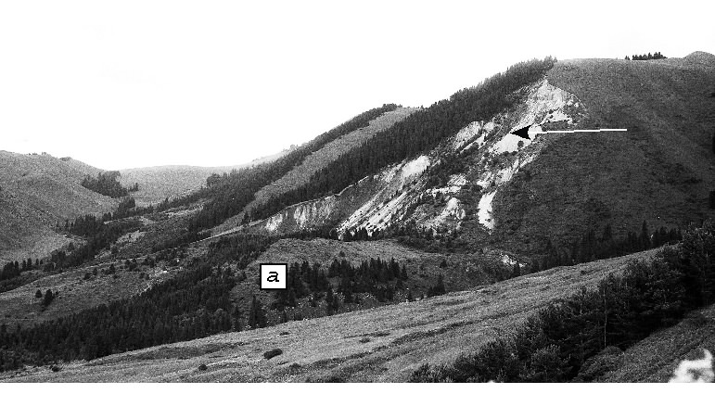
Fig. 3: Dzhidaashkir rock avalanche. Arrow shows the scar and "a" - rockfall body. Photo of 1991
by A. Korjenkov.
Below the rock fall there is a wavy surface, resembling the Kazakh hillocky area. West of the slide, below the Southern-Kemin Fault, is a step which is gently tilted northward, consisting of Neogene deposits and modified by small landslides (Fig 4A, B) and erosion cuts of temporary streams, along which a thick rock mass of ash-color loam is visible. Northward, the step contacts the fault at the field of wavy relief (Fig. 5).

A- small landslide to the south of Chonkemin settlement, arrows show the scar of the landslide, "a" - landslide body. | 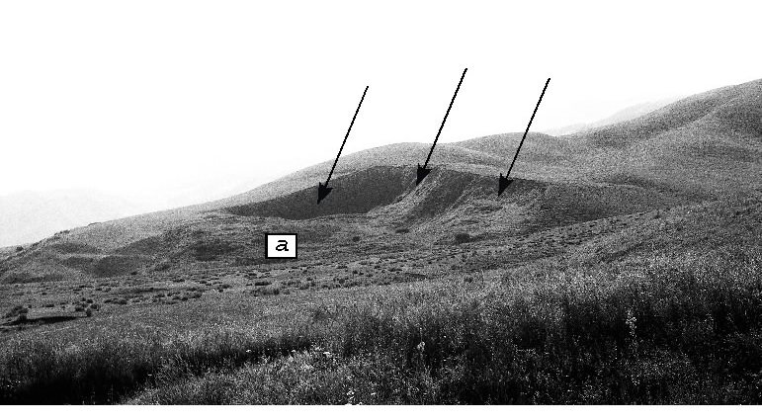
B - complicated gravitational form in the left slope of Sholakkayndy river, "a" arrows show the scar of the small landslide, "b" arrow shows a saddle - a possible scar of future landslide. Photos of 1991 by A. Korjenkov. | 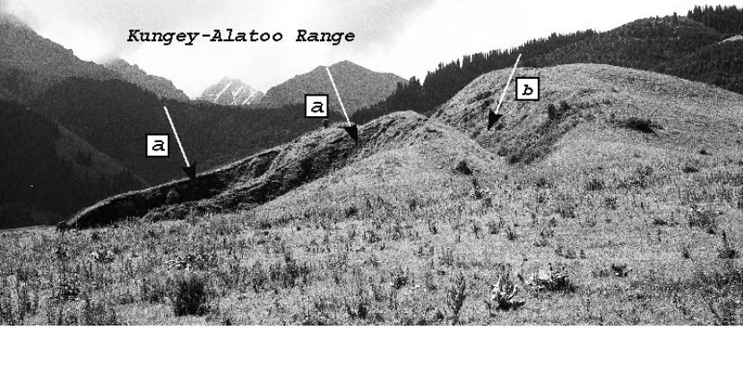
Fig. 4: Small landslides along the northern slope of Novorossyika foothills (adyrs), composed by mainly Neogene deposits covered by Quaternary sediments

Deposits:  1 – Holocene alluvial; 2 – Late Pleistocene alluvial; 3 – Mid Pleistocene fluvio-glacial,  4 – Miocene-Pliocene white-grey (N1-2),  5 – Oligocene-Miocene red-color (Pg3-N1);  6 – pre-Mesozoic rocks; seismo-gravitation formations: 7 – of 1911, 8 – Holocene,  9 – Pleistocene; 10 – fragments of erosional terraces; edges of terraces: 11 – QIII2,  12 – QIII1, 13 – QII2, 14 – QII1; 15 – scars;  16 – Neotectonic border faults; 17 – other faults, 18 - upslope facing scarps; 19 – strike-slip faults, 20 – thrusts; 21 – direction of gravitation displacement (flow) of masses; 22 – settlements. | 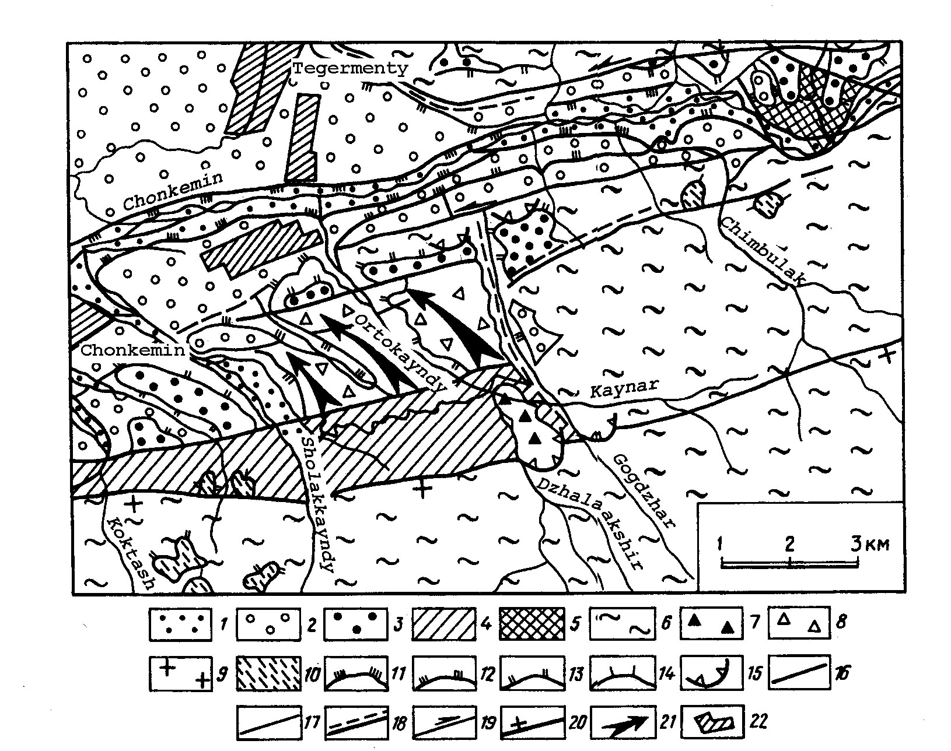
Fig. 5: . Eastern end of the Novorossyikadepression (modified after Chedia and Korjenkov, 1997).

The wavy field consists of sub-latitudinal stretched ridges divided by ravine-like lows dividing them, tilted from ESE to WNW (Fig. 6). Relative heights of the ridges are 15-20 m. Exposed in erosion cuts is ash-color loam with rounded boulders of gray amphibole granites. This rock mass is apparently constituted by fluvial-glacial deposits of Late Pleistocene. They in form of a fan are put in more high «front» ridge with the cover of Middle Pleistocene cobble round-stones, occurring on Miocene-Pliocene deposits.

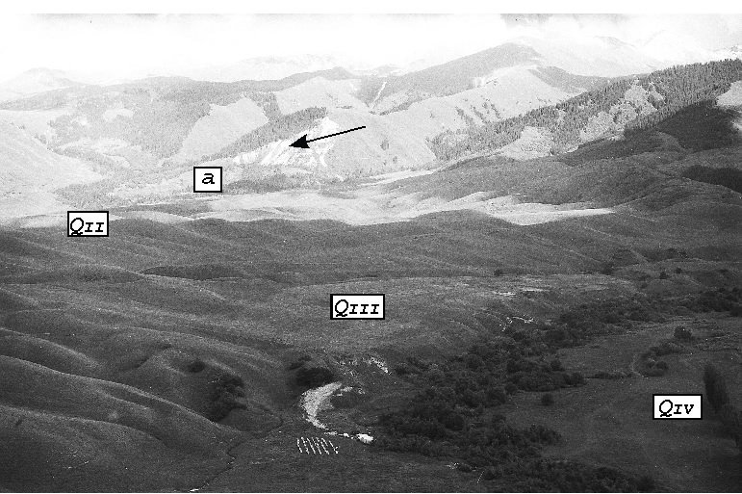

Fig. 6: Hillocky area of gravitation displacement (flow) of masses in the interfluve of Gogdzhar and Sholakkayndy rivers. Field of QII and QIII terraces is taught by gravitational displacement,
QIV terrace is not taught. An arrow shows the scar of the Dzhidaashkir rock avalanche and
"a" - rockfall body. Photo of 1993 by A. Korjenkov.

The Holocene terraces of these rivers are at heights of 2-3 m and have flat surfaces. They do not exhibit the wavy relief exhibited elsewhere or participate in ridge formation. The concentricity of the ridges is easily observed when viewed from the mouth of the Sholakkayindy River. The ridges are clearly older than the Holocene terraces. Ridges formation can be explained by the flow of significant rock mass of Late Pleistocene deposits accompanied by strong shaking which cause liquefaction, as with the 1991 Gissar Valley earthquake in Tadzhikistan. The seismic catastrophe most likely took place at the end of Pleistocene, since after formation of hilly-ravine relief it was cut by the rivers and terraces were formed. The area of sliding is an impressive - 12 km2 (3 x 4 km).
The eastern boundary of this tremendous landslide deserves special examination. It is almost straight and coincides with the Gogdzhar Fault, which is traced by typical seismic upslope facing scarp offsetting all streams crossing it. Along the smooth walls of this scarp up to a height of 15-20 m insufficient time has passed to allow development of erosion forms. The most northern part of the Gogdzhar Fault is shifted to the left 300 m along a latitudinal strike-slip fault. Coinciding with this fault is a boundary of a Late Pleistocene terrace (QIII1). The latitudinal part of an artificial channel is coincided to this seam. An artificial channel followed the rear seam 300 m returning father along to the sub-meridianal Gogdzhar Fault. The channel crosses QIII1 terrace mentioned above with its fluvial scarp of 60-70 m height, eventually sprawling on lower QIII2 terrace.
The Gogdzhar fault controlled the eastern boundary of the Neogene accumulation and is therefore active over a long time. The significant displacement along it and the formation of seismic upslope facing scarps probably occurred at the same time as the landslide described above, during an earthquake at the end of Pleistocene. The adaptation of this scarp as artificial channel occurred in historic time, although the exact date is unknown.

2.2 Dzhashilkyol locality of seismic deformations
A tremendous rock avalanche (Fig. 7) can be observed opposite the mouth of the Dzhashilkyol River. Along the left bank of Chonkemin River a large scar of shear formed in Riphean rocks, it is located to the Southern-Kemin Fault (Fig. 1). The scar width is 1,200 m, height of shear wall - 350 m. Rock avalanche travelled over the Chon-Kemin River Valley and sprawled along the opposite bank up to a fluvial scarp of 80-100 m height (QIII1). This mass dammed the Dzhashilkyol River near its mouth (Fig. 8) forming a lake. On the left bank only an insignificant part of slide mass remains. The slide mass is up to 2000 m width, 1200 m long, 140-150 m in thickness resulting in a volume - 36,000,000 m3. In the slide body three terraces have been formed by the Chon-Kemin River at heights of 5-7 m, 15 m, and 50-60 m (section E-F in Fig. 8). 200 m further upstream along the Chon-Kemin valley there is alluvial terrace of height 7 m, in which a 2-m section of clays rythmites testifying to the existence of a dam and subsequent lake during the formation of the rithmites. These clays apparently participated in the formation of 15-m terrace (QIV1) (section A-B in Fig. 8), since this higher terrace together with lower terrace form a single depositional unit.

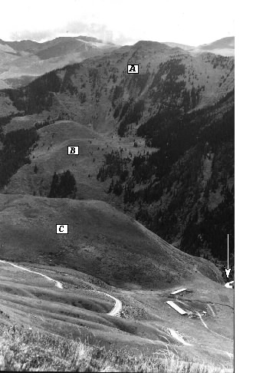 | Fig. 7: Photograph of the Dzhashilkyol rock avalanche in the Chonkemin river valley. A - a scar of the rock avalanche, B - rockfall body on the left slope of the Chonkemin river valley, C - rockfall body on the right slope, an arrow shows the Chonkemin river stream. Photo of 1991 by A. Korjenkov.

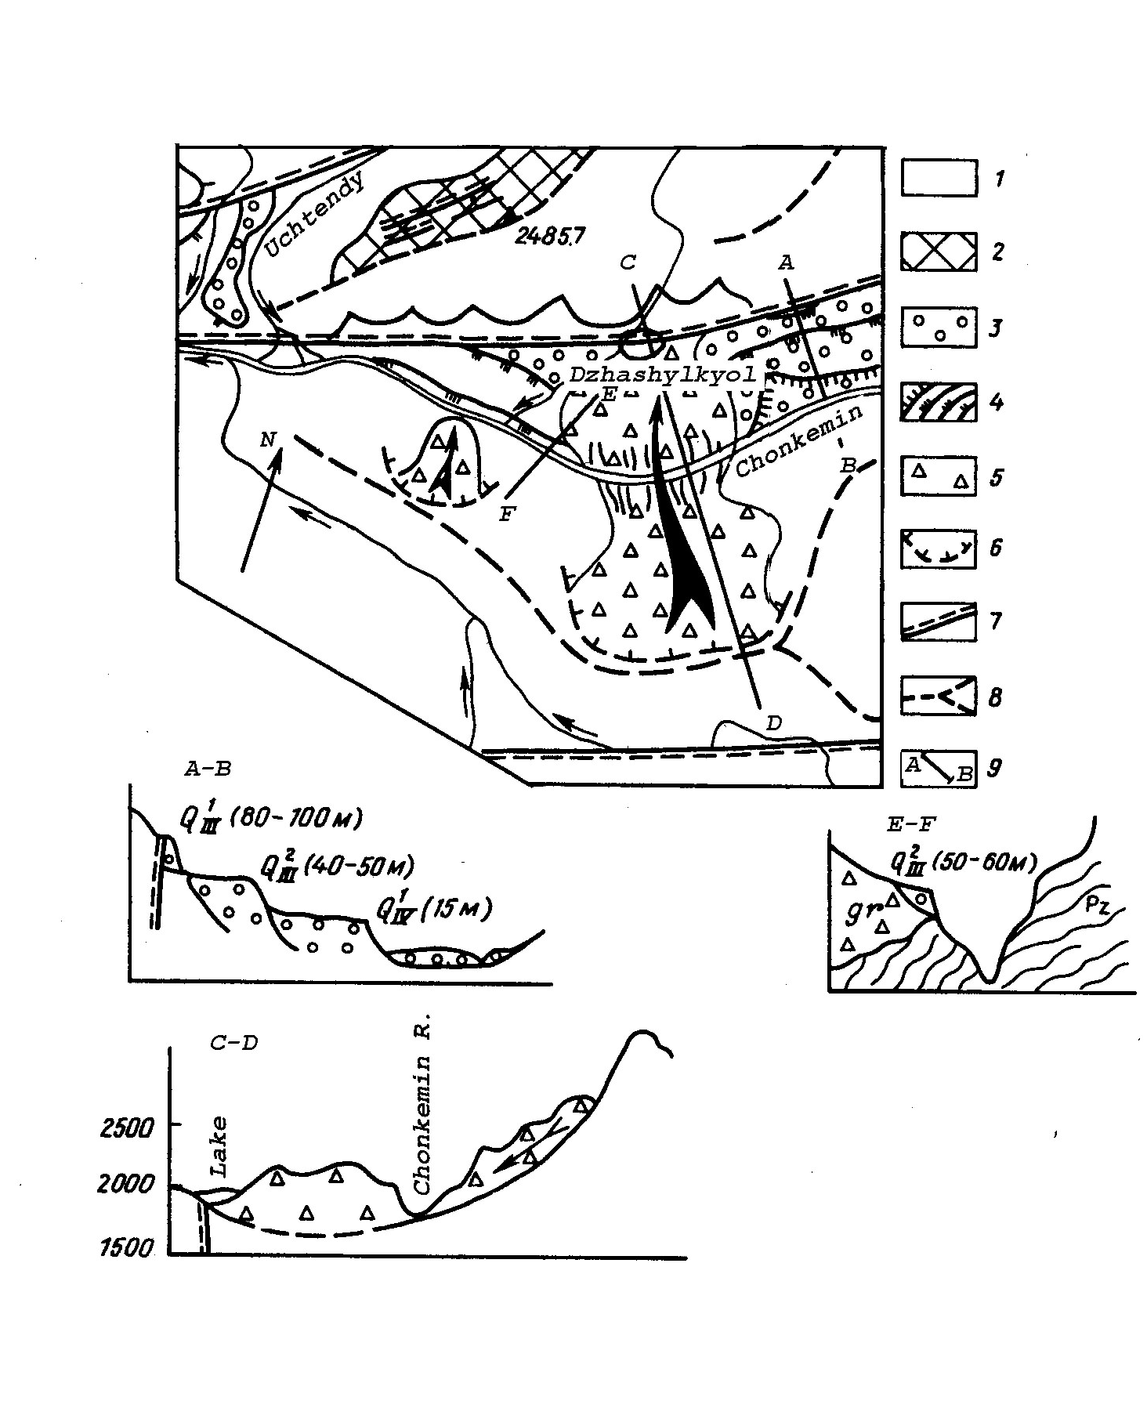

Fig. 8: Dzhashilkyol rock avalanche in the Chonkemin river valley (Modified after Chedia and Korjenkov, 1997).
1 – Lower Paleozoic and Pre-Cembrian formations, 2 – fragments of epi-Hercinian peneplain, 3 – Quaternary alluvial deposits, 4 - edges of terraces: QIV1, QIII2, QIII1, QII2, 5 – rock avalanche formations; 6 – scars, 7 – neotectonic ruptures; 8 – watersheds, 9 – lines of sections.

Near the lower part of the slide body a fragment of erosional terrace of height of 50-60 m (QIII2) is found. Lower the slide body the terrace rapidly decreases in height to 35 m and includes non-rounded fragments from the slide mass. The rock avalanche could therefore have occurred between formation of two Late Pleistocene terraces (QIII2 and QIII1), in the beginning of Late Pleistocene, not in the Holocene as it was supposed by V. Kuchay (1969).
Lake Kyolkogur (Fig. 9) is dammed be a slide mass fallen from the right slope of the Kyolkogur River at its mouth. The slide mass covers the valley up the QII2 terrace level. In the slide body are traces of a younger landslide which moved downstream along Kyolkogur River valley. The debris jumped the bed of the Chonkmin River and sprawled across a terrace at 5-m height. Another younger, smaller rock avalanche is located in the upper part of Dzhashikyol Spring valley.

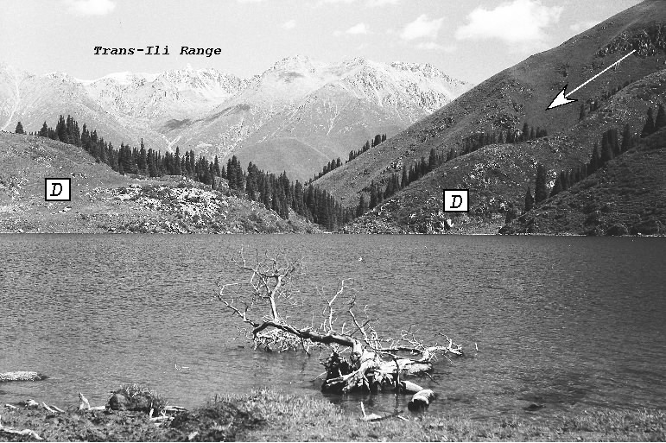

Fig. 9: Dammed Kyolkogur Lake. D - the dam body, an arrow shows the scar of the rock avalanche. Photo of 1991 by A. Korjenkov.

Age of the last two rock avalanches, according to described data, - is the first half of Holocene. At the same time, numerous cracks were formed in that slope part which was not involved into the movements. These cracks have prepared this part of the slope to future collapse during next earthquake. At the same region in the valleys of Chetendy and Ichkesu rivers there is abundance of upslope facing scarps of 200-300 m length of the same (early Holocene) age according to their preservation.

Except for the paleoseismic deformations described above, seismic origin of which is clear, there are some problematic forms. Thus, eastward of Kyolkogur Lake it is observed a clear scar of completely "ideal" form, diameter of which is up to 3 km (Fig. 10a). Its walls are highly even, if not to count small-thickness colluvium's deposits. Along the foot of this "circus" with walls' heights up to 300-400 m there is an upslope facing scarp which apparently traces the correspondent fault. Along the upslope facing scarp the bottom of the circus adjoins to the southern steep slope of 2838.3 summit composed by the basement rocks. There are two ways to explain this phenomenon: either the whole mount has slipped down into Chonkemin river valley (Fig. 10b), or the bottom of the scar is covered by thick mass of gravitational deposits which are supported by massif of the mentioned above summit slightly thrown northward (Fig. 10C). Since the lower parts of the slope of the Kungey-Alatoo Range are abundantly covered by the slope deposits, the question remains opened until large volume of excavation work for the exposure of supposing bed of the landslide.

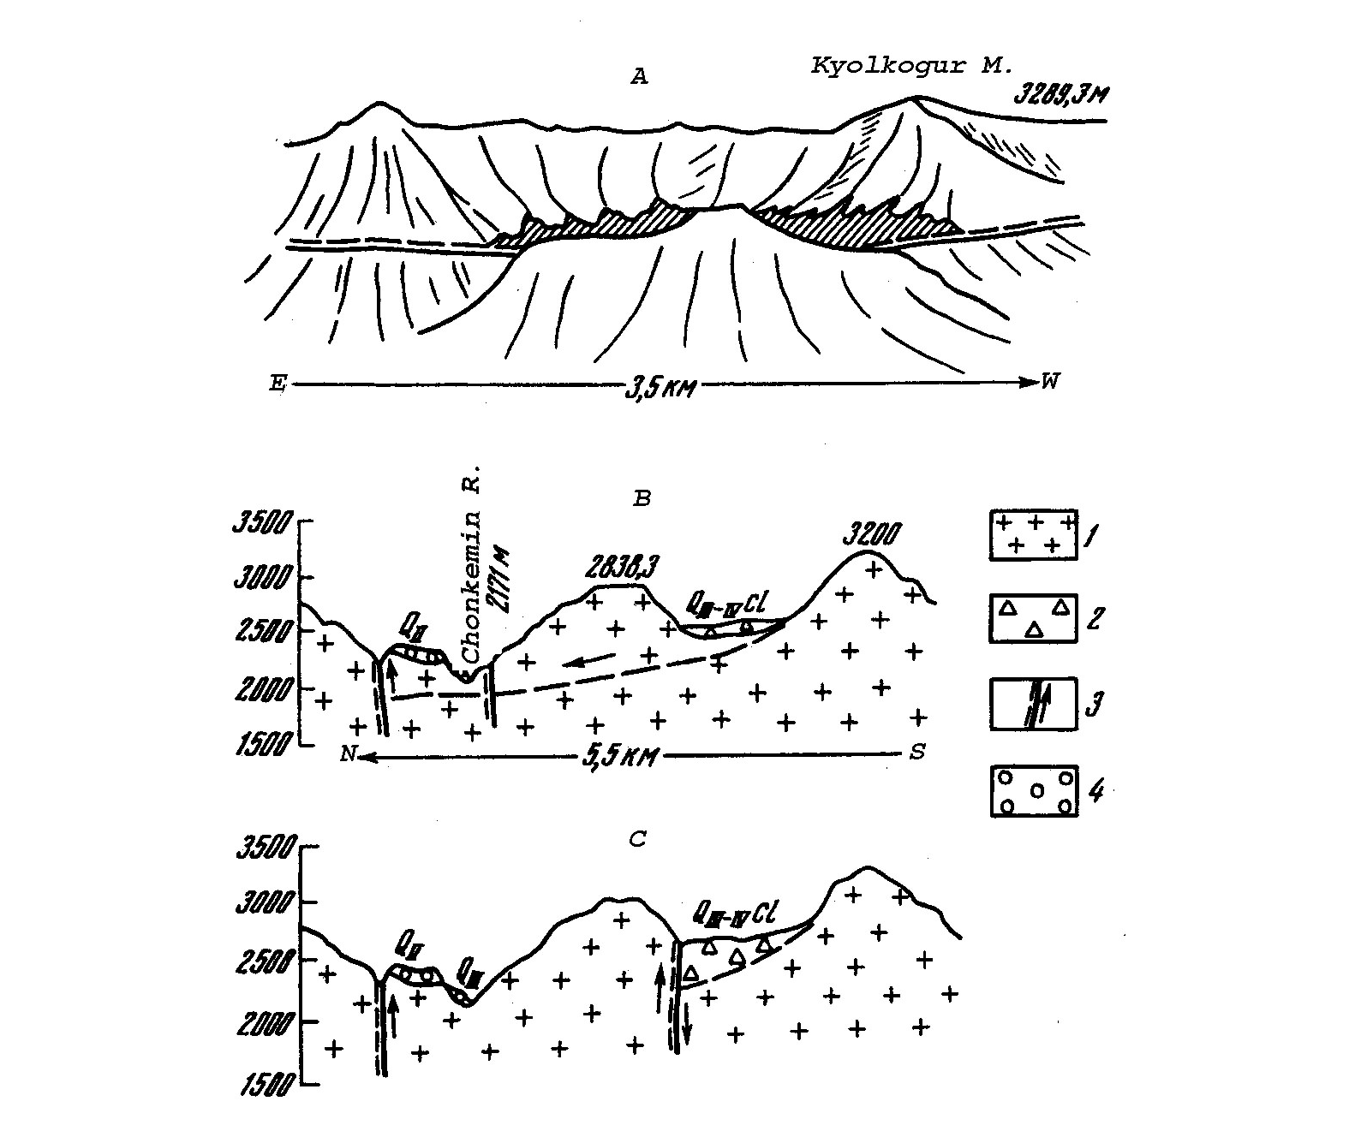

Fig. 10: Problematic formations of summit 2838.3 m (modified after Chedia and Korjenkov, 1997). A – general view from the northern watershed of the Chonkemin valley, B and C – probable variants of the structure (see, text for discussion). 1 – Lower Paleozoic and pre-Cembrian formations, 2 – gravitation deposits, 3 – ruptures, 4 – alluvial deposits.

Nowhere in the Chonkemin river valley such formations were met. Age of this problematic form is Middle Pleistocene charging by its relation to the river terraces. If it was caused by the earthquake, its intensity had to be not lees than I=X-XI.

2.3 Dzhaya locality of the seismic deformations
There are also numerous residual forms of relief of seismotectonic, seismogravitational and of transitional gravitational-seismotectonic genesis in the Dzhaya locality of the seismic deformations.

Numerous spectacular evidences of ancient seismic catastrophes, fixing the epicentral zones, one can observe in the southern slope of the Trans-Ili Range. They are mainly of ENE strike and of first kilometers length. Southern (lower) upslope facing scarp coincides with the line of recent thrust - strike-slip fault (Fig. 11) which is border for the small Dzhaya graben-syncline, maximum depth of which is near to the described tectonic contact (Fig. 12A). Here one can observe tectonic dams, and also rounded smooth subsidences of the ground in the fault zone. All described upslope facing scarps are strongly turfed and significantly overlapped by the slope deposits. Their age is Holocene according to their preservation.

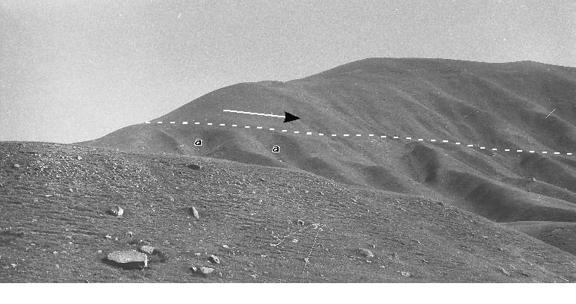
Fig. 11: Photograph of the right-lateral strike-slip fault in the right slope of the Chonkemin river
valley in the Dzhaya locality. Trace of the fault is shown by the dashed line, an arrow
shows the movements along the fault, "a" - beheaded gullies cut by the fault. Photo of
1993 by A. Korjenkov.

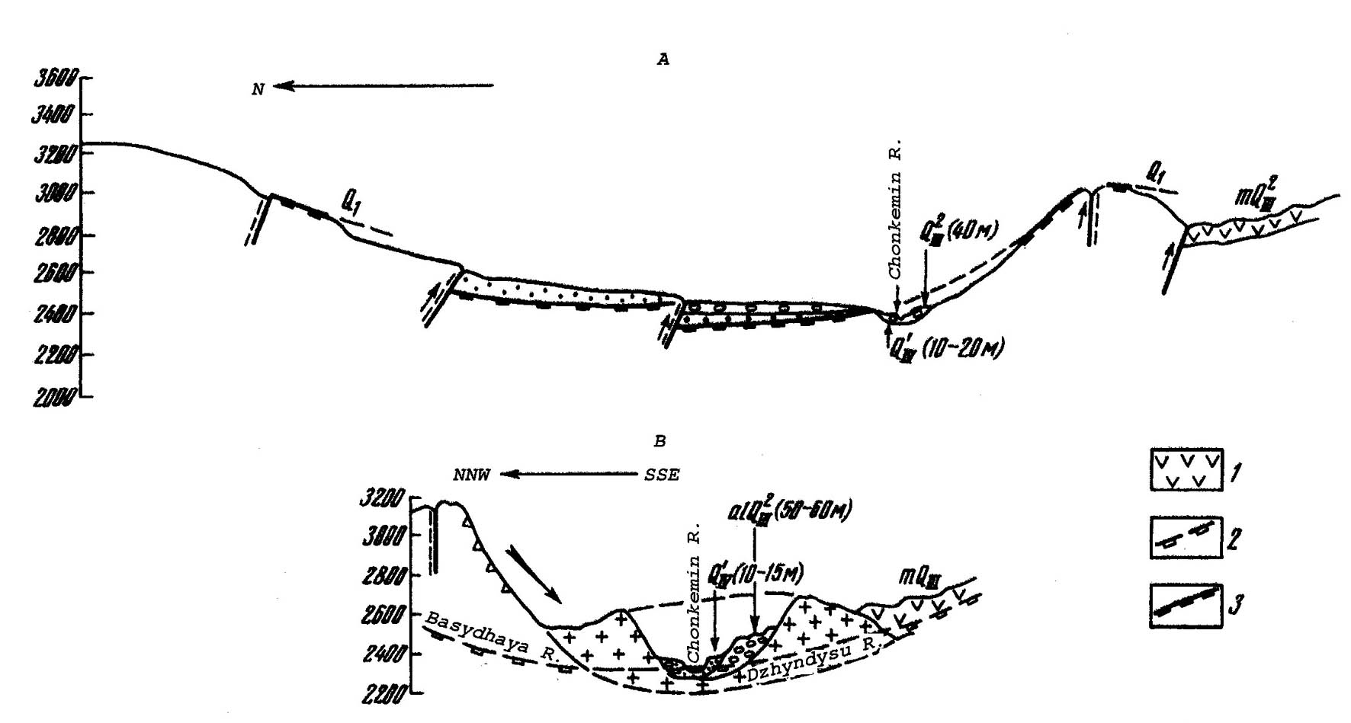

Fig. 12: Longitudinal profiles (modified after Chedia and Korjenkov, 1997): A – across the Dzhaya locality, B – across the Basydzhaya rock avalanche. 1 – Late Pleistocene morains, 2 – river talveg in longitudinal profile, 3 – lower Pleistocene leveled surface. For other symbols – see in Fig. 5.

Holocene tectonic movements within the described territory are also fixed by the fault separating the Aytymbet horst-anticline in the south from the megastructure of Kungey Ala-Too. The fault zone itself can be observed on the slopes of antecedent part of Chemchek spring valley. Flysch rock masses in the fault zone are significantly worn out. Additionally to the significant general vertical amplitude of movements along the fault (up to 1 km during the whole Quaternary period) left-lateral strike-slip faulting also took place. Thus, at tracing of the fault line in the Kashkasu-Chemchek interfluve along the streams cutting the Aytymbet anticlinal structure, one can observe "pockets" formed by the surfaces of Holocene terraces. Average width of such "pockets" is about 50 m. Vertical displacements on the uplifted northern side of the fault are 1-4 m determined from the described Holocene terraces. Thus, Southern Kemin Fault separating here the Kungey and Aytymbet ranges is represented by strike-slip-thrust fault. The fault zone is marked also by the abundant springs and swampy areas formed because of tectonic damming. Moreover, in the watersheds between the streams above the fault zone, covered by the upper-Pleistocene moraine, one can observe the hills and depressions that is evidence of ground subsidences or filling of gaping emptinesses appeared during earthquakes.

Seismotectonic scarps of sub-latitudinal and ENE strike can be also observed in the right slope of the Chonkemin river valley in the Dzhaya locality. Their height reaches the first tens of meters. And although they are developed in the field of spreading of the loose Quaternary deposits, the basis of their formation was the movements of consolidated basement composing the Dhzya Quaternary graben-syncline. These rocks, covered by thin cover of alluvium, can be observed in the structure of some scarps.

Longitudinal cracks (wedges) of the watershed part of the Aytymbet ridge can be attributed to the intermediate gravitation-tectonic deformations. The wedges are stretched in sublatitudinal direction. Their general length is up to 2 km at the length of single rupture of the first hundreds meters, width is up to 10 m, and depths are 1-2 m. It is necessary to note their significant turfing and covering by slope deposits. Analogous forms are spread in the left watershed of the Basy-Dhzaya stream. The watershed tilted toward south-west is completely broken by cracks of SE strike.

Eastward of the described watershed one can observe a spectacular example of one more seismogenic form of relief - seismogravitation rock avalanche of basement rocks with a scar in right slope of the Chonkemin river valley (Fig. 12B). The scar is significant: its width reaches 800 m, and height of the detachment wall, partly covered by the collapsed mass, is almost 1000 m. Volume of the collapsed mass is also significant - millions of cubic meters. During the shock the disintegrated rocks collapsed down and overflowed onto opposite slope of the river valley (Fig. 13). Late-Quaternary moraine of the Dzhindysu stream rests on a rockfall body, that allow us (Chedia and Korjenkov, 1997) dating it by the end of Middle - beginning of Late Pleistocene. The Quaternary alluvial terraces also point this age. Thus, the Chonkemin river has produced two terraces of 7-10 m and 15 m height in the body of the rockfall; moreover, lower the rockfall body, close to it, along the river flow it was formed a number of local Late Pleistocene sculptured-accumulative terrace of 35, 42, 50 and 60 m height formed by gradual rewashing of collapsed rock mass. Delvaux et al. (2001), however, reported younger age of the rockfall. They supposed that the rockfall body lies on the Late Pleistocene moraine body and its age is 6-7 ca determined by C14 AMS method. Additional study of this gravitational form is necessary.

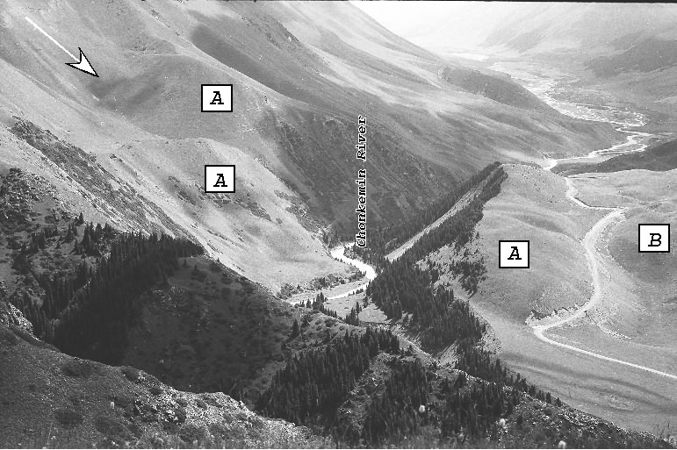

Fig. 13. Photograph of the Dzhaya rock avalanche. An arrow shows the scar of the rockfall, A - the rockfall body, B - Late Pleistocene moraine. Photo of 1991 by A. Korjenkov.

There are younger seismogravitational formations in the right bank of the Chon-Kemin river valley. These are two earthflows of colluvial-alluvial loose material. A scar of one of them reaches 300 m in length and 15 m in height. Volume of the earthflow body is 250 m3 at length of 500 m, width of 50 m and thickness of 10 m. Almost whole surface of the earthflow is soil-covered with the exception for edges of the scar. This fact allows us consideration that given earthflow was formed during the earthquake of 1911. The scar of the second earthflow is even larger and, consequently, volume of its mass is also larger.
Presence of full spectrum of all types of seismic deformations in the Dzhaya locality apparently is not occasional. It ties with a pericline of growing Aytymbet horst-anticline, young Quaternary Dzhaya graben-syncline and faults of thrust and strike-slip types active in Holocene. Described residual deformations, especially seismic upslope facing scarps, testify to numerous seismic ruptures which reached the surface in this place, and different preservation of the seismic deformations shows long-term reoccurrence of the seismic events to certain segments of the seismic zone.

3 Assessment of magnitude of paleoearthquakes
For the assessment of magnitudes (M) of earthquakes occurred in the Chonkemin river basin within four segments of the seismic zone we have used the formulae by A. A. Nikonov (1981, 1984) deduced for mountain regions of the Central Asia:
M1 = 7.23 + 0.32 lg l, s2 = 0.58, r = 0.45; (1)
M2 = 6.61 + 0.55 lg L, s2 = 0.39, r = 0.81; (2)
M3 = 7.09 + 0.79 lg D, s2 = 0.42, r = 0.72; (3)
M4 = 6.84 + 0.61 lg b, s2 = 0.47, r = 0.71; (4)
M5 = 6.41 + 1.31 lg h, s2 = 0.64, r = 0.53; (5)
where L - length of rupture zone on the surface, km; l - length of a single rupture, km; D - a value of displacement along the rupture, m; b - width of an upslope facing scarp or crack, m; h - depth of the upslope facing scarp or crack, m; s - chi square probability, r - correlation coefficient. It is necessary to use maximum values of sizes of linear seismic deformations. The accuracy of assessment is in limits of ±0.5 of magnitude unit (Table).

Table. Determination of earthquake magnitudes in the Chonkemin river basin

Localities | Parameters of paleoseismic deformations |  |  |  |  |  | Magnitude assessments
 | b, m | h, m | D, m | l, m | L, m | M₁ |  | M₂ | M₃ | M₄ | M₅ | M_{average}
Onarchek (lower part of the Chonkemin river valley) | 15 | 4 | - | 0.15 | 2 | 7.24 |  | 6.78 | - | 7.55 | 7.09 | 7.17
Togyzbulak (Togyzbulak stream - right tributary of the Chon-Kemin river valley) | 15 | 6 | 15 | - | 6 | - |  | 7.04 | 8.02 | 7.56 | 7.29 | 7.48
Dzhashilkyol (Dzhashilkyol lake) | - | 6 | 25 | 0.2 | 5 | 7.01 |  | 6.99 | 8.19 | - | 7.29 | 7.40
Dzhaya (Dzhaya locality) | 10 | 4 | 10 | 2.5 | 6 | 7.36 |  | 7.04 | 7.88 | .45 | 7.09 | 7.36

Earthquakes of the magnitude 7.2-7.5 generate a surface effect of seismic intensity up to I = X by MSK-64 scale (Korjenkov and Omuraliev, 1993; Bogachkin, et al., 1997; Ghose et al., 1997).

4 Conclusions
Similar seismic deformations continue upstream along the Chonkemin River Valley. The authors conclude first that within the mezoseismal zone of the Kebin earthquake (1911, M = 8.2, Chon-Kemin Valley) geomorphic evidences of paleoearthquakes of similar magnitude are found. The traces of strong earthquakes in the form of fault scarps and mass movements , such as landslides and rock avalanches, are well preserved in the local relief. These paleoseismic deformations are determined to be Holocene, Late Pleistocene and even Late-Middle Pleistocene in age by geologic and geomorphologic correlations with the local, relative Pleistocene chronology of river terraces and glacial moraines. All of these features are located along Chilik-Kemin Seismic Zone, supporting the hypothesis that seismogenic zones are stable and paleoseismic deformations well preserved over these time periods. Secondly, seismic activity during the Pleistocene, and continueing through the Holocene till present (1911) is strongly indicated by strike-slip related offsets of Holocene springs, fault scarps with different degree of preservation, catastrophic rock avalanches and landslides, liquefaction features and damming of rivers. Seismic intensity responsible for the formation of these deformations and features should be IX or greater using the MSK-64 scale.

These conclusions coincide with that reported by A. K. Trofimov (1993) on formation of Central Issyk-Kul graben in Mid Holocene. Formation of recent left-lateral strike-slip faults on the west of described area and right-lateral strike-slip faults in the east can be explained by some displacement toward NNW of a significant fragment of the Issyk-Kul Median Massif indenting at right angle into the system of Kungey-Alatoo range in the region of the Tory-Aygyr river valley. This circumstance is resulted in the angular junction of neotectonic Western-Kungey meganticline of northeastern strike and Central-Kungey one of latitudinal strike (Chedia, 1986). Apparently, the seismic activity of described region is related to this process.

5. Directions of future investigations

5.1 Revealing the paleoseismic deformations using satellite imagery
The field mapping of paleoseismic deformations has to be followed by study of traces of ancient seismic catastrophes using detailed satellite images, like recently declassified US satellite images CARONA and analogous former Soviet materials. Composing the map of paleoseismic deformations on the basis of satellite images will allow us fulfillment the existed gaps in seismic hazard and risk analysis of the Kyrgyzstan territory.

5.2 Computer modeling of stress-strain state of landslide massifs
Computer modeling the landsliding of the chosen test objects, where seismic origin and multiple landslide occurrences are proved. This approach will allow us better understanding of their trigger mechanisms and, possibly, contouring the scar formation of the future rock avalanches and landslides.

Acknowledgements. Field data for this paper were obtained together with O. K. Chedia, K. A. Abdrakhmatov, D. Bowman, S. Ghose and I. N. Lemzin in 1991, 1993, 1995, and 2002. A. M. K. thanks them very much for their help in the field and fruitful discussion of the materials. The work on this paper became available due to financial support of US CRDF (grant YG2-2542-B1-03).

References
Ai N., Liu B., Zhou J. Great earthquakes and their geomorphological effect. Z. Geomorphol. 1987. Supplementbd. V. 63. Pp. 159-165.
Bogachkin B. M., A. M. Korzhenkov, E. Mamyrov, Yu. V. Nechaev, M. Omuraliev, A. E. Petrosyan, K. G. Pletnyov, E. A. Rogozhin, and T. A. Charimov. The Structure of 1992 Susamyr Earthquake Source Based on Its Geological and Seismological Manifestations. Izvestiya. Physics of the Solid Earth. Vol. 33, No. 11, pp. 867-882.
Bogdanovich, K. I., Kark, I. M., Korolkov, B. Ya., and Mushketov, D. I. 1914. Earthquake in the Northern Districts of Tien Shan, 22, December 1910 (January, 4, 1911). Saint Petersburg, Commission of Geology Committee, 270 p. (In Russian).
Bollinger G.A., Costain J.K. Longterm cyclicities in earthquake energy release and major river flow volume in Virginia and Missuri seismic zones. Seismological Research Letters. 1988. V. 59. No. 4. Oct.-Dec. Pp. 279-283.
Carton A., Dramis F., Sorriso-Valvo M. Earthquake landforms: Observations after recent Italian and Algerian seismic events. Z. Geomorphol. 1987. Supplementbd. V. 63. Pp. 149-158.
Chedia, O. K. 1986. Morphostructures and Neotectonic Tectogenesis of the Tien Shan. Frunze, “Ilim” Press, 314 p. (in Russian).
Chedia, O. K. 1990. Aksu graben in the neotectonic structure of the Kungey-Alatoo range. Proceedings of Academy of Sciences, Kirgiz SSR. Physic, Technical and Mathematic Sciences. No. 1, p. 68-79 (in Rissian).
Chedia, O. K., and A. M. Korjenkov. Long-term preservation of geomorphic traces of ancient seismic catastrophes (in Russian). Geomorphology, No. 3. Pp. 88-98.
Delvaux, D., K. E. Abdrakhmatov, I. N. Lemzin and A. L. Strom. 2001. Landslides and surface breaks of the 1911 Ms 8.2 Kemin earthquake, Kyrgyzstan. - Geology and Geophysics, vol. 42, No. 10, p. 1667-1677 (in Russian).
Experience of Complex Seismic Zoning on the Example of Chu Depression. 1975. Frunze, “Ilim” Press, 190 p. (in Russain).
Ghose, S., R. J. Mellors, A.M. Korjenkov, M. W. Hamburger, T. L. Pavlis, G. L. Pavlis, M. Omuraliev, E. Mamyrov, and A. R. Muraliev. The Ms = 7.3 1992 Suusamyr, Kyrgyzstan earthquake in the Tien Shan: 2. Aftershock focal mechanisms and surface deformation. Bulletin of Seismologic Society of America. Vol. 87, No. 1, Feb. pp. 23-38.
Goryachev, A. V. 1959. Mesozoic-Cenozoic Structure, History of Tectonic Development and Seismicity of the Issyk-Kul Lake Region. Moscow, Publishing House of Academy of Sciences, USSR, 180 p. (In Russian).
Gubin, I. E. 1960. Regularities of Seismic Manifestations on the Tadzhikistan Territory. Moscow, Publishing House of Academy of Sciences, USSR, 464 p. (In Russian).
Kachaganov, Sh. K. 1975. Geomorphologic map of the Chon-Kemin river basin as a basis for morphostructural analysis. - In: Structural Geomorphology of Mountain Countries. Moscow, Nauka Publishing House, p. 170-175 (in Russian).
Korjenkov, A. M. 1988. General Peculiarities of Neotectonic Structural Forms of the North-Eastern Tien Shan (in Russian). Author-Essay of Dissertation for Obtaining the Scientific Degree of Candidate of Geological and Mineralogical Sciences (Ph. D.). Frunze. 21 pp.
Korjenkov, A. M. 1995. Geological records of strong earthquakes in the northern Tien Shan. - Annales Geophysicae. XX General Assembly of EGS. Apr. 3-7, 1995. Hamburg. Germany. Part I: Society Symposia, Solid Earth Geophysics & Natural Hazards. Supplement I to vol. 13. Abstracts. P. C211.
Korjenkov, A. M. 1998. Long-Term Preservation of Traces of Ancient Seismic Catastrophes, Chon-Kemin Valley, Kyrgyzstan. The Second Meeting of Asian Seismological Commission and Symposium on Earthquake Hazard Assessment and Earth's Interior Related Topics (Dec. 1-3, 1998) National Geophysical Research Institute, Hyderabad, India. Abstracts. P. 52.
Korjenkov, A. M. 2000. Cenozoic tectonics and seismicity of northwestern part of the Issyk-Kul depression (Tien Shan). Russian Geology and Geophysics. Vol. 41. No. 7.
Korjenkov, A. M., and Charimov, T. A. 1993. Chonkurchak locality of the seismic deformations - an evidence of repeated seismic catastrophes near Bishkek city. - In: Yankevich, T. Ya. (ed.) Actual Questions of Geology, Geophysics and Seismology. Bishkek, Ilim Publishing House, p. 7-14 (in Russian).
Korjenkov, A. M., and Chedia, O. K. 1986. Neotectonic structure and seismic deformations of the Tyulek and Karakudzhur depressions. Proceedings of Academy of Sciences, Kirghiz SSR, No. 5, p. 26-33 (in Russian).
Korjenkov, A. M., and Chedia, O. K. 1999. Long term preservation of strong paleoearthquake traces in the Chilik-Kemin seismogenic zone, Chon-Kemin valley, northern Tien Shan. - Terra Nostra, No. 2. (14th Himalaya-Karakoram-Tibet Workshop. Kloster Ettal, Germany, March 24-26, 1999. Abstract Volume), p. 86-88.
Korjenkov, A.M. and M. Omuraliev. Forms of relief formed during strong Suusamyr earthquake (1992) in the northern Tien Shan. (In Russian). - Geomorphologic Risk. II Lectures for Memory of N. A. Florensov. Nov. 1993. Irkutsk Geomorphologic Seminar. Abst. Irkutsk. Pp. 105-106.
Kuchay, V. K. 1969. Results of repeated investigation of residual deformations in the mesoseismal area of the Kebin earthquake. Russian Geology and Geophysics. No. 8.
Kuchay, V. K. 1971. Use of paleoseismic deformations at study of seismic regime (on example of the mesoseismal area of the Chankal earthquake of 1946). Collection of Geology and Geophysics Department of Sibirian Branch of Academy of Science of USSR. No. 4, p. 28-31 (in Russian).
Kuchay, V. K. 1972. Peculiarities of maximum seismic effect from paleoseismogeologic data. Russain Geology and Geophysics. No. 12.
Leonov, N. N. 1965. Role of geological structure in formation of residual deformations in the grounds during earthquake. Transactions of the Institute of Physics of the Earth. No. 36 (203), Issue 10, p. 132-136 (in Russian).
Morner N.-A., Somi E., Zuchiewicz W. Neotectonics and paleoseismisity within the Stockholm intercratonal region in Sweden. Tectonophysics. 1989. V. 163. No. 3-4. P. 289-303.
Nesmeyanov, S. A. and Barkhatov, I. I. 1982. Structure of neotectonic ruptures in Near-Issykkul and Kungey-Trans-Ili region. – In: Complex Scientific Investigations in Engineering Investigations for Construction. Moscow, p. 37-49 (in Russian)
Nikonov, A. A. 1977. Holocene and Recent Movements of the Earth Crust. Moscow, “Nauka” Press, 239 p. (in Russian)
Nikonov, A. A. 1981. Use of radiocarbon dating for age assessment of ancient earthquake in the mountains of southern Middle Asia. Izvestiya. Physics of the Solid Earth. No. 9.
Nikonov, A. A. 1984. Development of paleoseismogeologic method for the seismic hazard asessment in Middle Asia. – In: Geological and Geophysical Study of the Seismically Dangerous Zones. Frunze, “Ilim” Press, p. 192-203 (in Russian).
Omuraliev, M., and Charimov, T. A. 1990. Seismic deformations and seismic hazard of western part of Northern Kirgizia. Proceedings of Academy of Sciences of Kirgiz SSR. Physic, Technical and Mathematic Sciences. No. 4, p. 83-88 (in Russian).
Patalakha, E. I., and Chabdarov, N. M. 1976. Conditions of relief formation of northern Tien Shan and probable mechanism of the process. – In: Seismotectonics of Some Regions of the South of USSR. Moscow, “Nauka” Press, p. 80-90 (in Russain).
Savage J.C., Burford R.O. Geodetic determination of relative plate motion in Central California. J. Geophys. Res. 1973. V. 78. No. 5. Pp. 832-845.
Solonenko, V. P. 1973. Paleoseismogeology. Izvestiya. Physics of the Solid Earth. No. 9.
Tokombaev, Sh. 1963. Some surface forms of the Chon-Kemin river valley and the Boom gorge caused by earthquakes. – In: Geographic Investigations of High-Mountain Depressions of Kirgizia in relation to their development. Frunze, “Ilim” Press, p. 144-147 (in Russian).
Trifonov, V. G. 1971. Character of tectonic movements in the areas of neotectonic orogeny (the Kopetdag and Southeastern Caucasus). Geotectonics. No. 4
Trifonov, V. G. 1983. Late Qauternary Tectonogenesis. Moscow, “Nauka” press, 234 p. (in Russian).
Trofimov, A. K. 1993. Quaternary tectonics. – In: (Abdrakhmatov, K. E. - ed.) Detailed Seismic Zoning of the Issyk-Kul Depression. Bishkek, Ilim Publishing House, p. 39-44 (in Russian).
Utirov, Ch. U. 1978. Seismic deformations. – In: Geological Principles of the Seismic Zoning of the Issuk-Kul Depression. Frunze, “Ilim” Press, p. 91-111 (in Russian).
Wallace R.E. Earthquake recurrence intervals on the San Andreas fault. Bull. Geol. Soc. America. 1970. V. 81. No.10. Pp. 2875-2890.

