Kartographische Bausteine
Band 28
Dresden 2004

Proceedings of the 7th

INTERNATIONAL SYMPOSIUM
ON
HIGH-MOUNTAIN REMOTE SENSING
CARTOGRAPHY
(HMRSC VII)

held in
Bishkek, KYRGYZSTAN
July 15 – 26 2002




Editor:
Manfred F. Buchroithner, Dresden

Desktop Publishing:
Robert Hecht

Printed by:
Dresden University of Technology
Institute for Cartography (KTE)

High Mountain Remote Sensing Cartography VII (HMRSC VII)
Ed. by Manfred F. Buchroithner, Institute for Cartography of the Dresden University of Technology, 2004. Kartographische Bausteine, Band 23, Dresden 2004.
ISBN: 3 - 86005 - 435 - X

© Institute for Cartography of the Dresden University of Technology
Dresden 2004
ISBN: 3 - 86005 - 435 – X

Andrey M. Korjenkov, E. Mamyrov, M. Omuraliev, V. A. Kovalenko,
S. F. Usmanov

Rock Avalanches and Landslides Formed in Result of Strong Suusamyr (1992, M = 7,4) Earthquake in the Northern Tien Shan - Test Structures for Mapping of Paleoseismic Deformations by Satellite Images

1 Introduction
Seismic deformations are formed in mezoseismal zones of strong earthquakes. They reflect features of radiation of seismic energy, geologic-geomorphologic and geophysical conditions of a region. Study of seismic deformations is necessary for understanding of origin and mechanism of seismic affects in the grounds, and also for reconstruction and prognosis of seismicity and seismic regime of a certain region.
During Suusamyr earthquake (M_{s} = 7,4; I_{o} = IX-X; 19.08.1992) in northern Tien Shan, a number of seismic deformations of different types were formed, among which gravitational-seismotectonic and seismic-gravitation deformations had wide distribution. Although the earthquakes occurred in the area of rare population, more than 40 people were killed; numerous building constructions were damaged significantly. This strong earthquake was an absolute unexpectedness for local seismologists: according to the Map of Seismic zoning of Kyrgyzstan for 1977 (Dzhanuzakov et al., 1977) the area of Suusamyr depression belongs to the zone of the seismic intensity I = VII-VIII.
Immediately after the earthquake, detailed study of its consequences was conducted (Korjenkov and Omuraliev, 1993, Korjenkov, 1996, Bogachkin et al., 1997, Ghose et al., 1997). Field research and also aerial photograph interpretation define more precisely positions of old residual seismic deformations in the Suusamyr depression and surrounding regions known earlier (Omuraliev and Charimov, 1990), which had been formed during paleoseismic catastrophes.
This paper dedicated to the description of recent seismic deformations and also paleoseismic features in the Suusamyr depression and surrounding ranges revealed by the field mapping and air-photographs interpretation. Thus, the Suusamyr depression is an excellent natural laboratory for learning the seismic deformation peculiarities and its formation. Then, we can spread our knowledge of recent earthquakes onto ancient seismic catastrophes occurred in the Suusamyr depression as well as in the whole Tien Shan territory in the past. Such regional study conducted with use of detailed satellite images will allow creation a database of gravitational deformations. This database can be a basis for re-assessment of seismic and landslide hazard in Kyrgyzstan.

2 Geological setting
Geological setting Suusamyr earthquake is intracontinental one. It occurred in the northern part of the Tien Shan Mountains which occupies specific position in the structure of global lithosphere plates. The complex of lithosphere plates interact here. Main tectonic forces are applied from Indian and Eurasian plates (Molnar, Tapponier, 1975, 1977). The Tien Shan as a mountain system was formed during Neotectonic stage of development
of the earth lithosphere between Kazakh shield, Turan plate in the north and Tarim platform, Pamir mountain system in the south (Fig. 1). The Tien Shan is one of seismically dangerous regions of the Earth where there was a number of historical earthquakes (Chilik and Kebin ones with magnitudes of more than M>8) and paleo-catastrophes. All the earthquakes are crustal here.

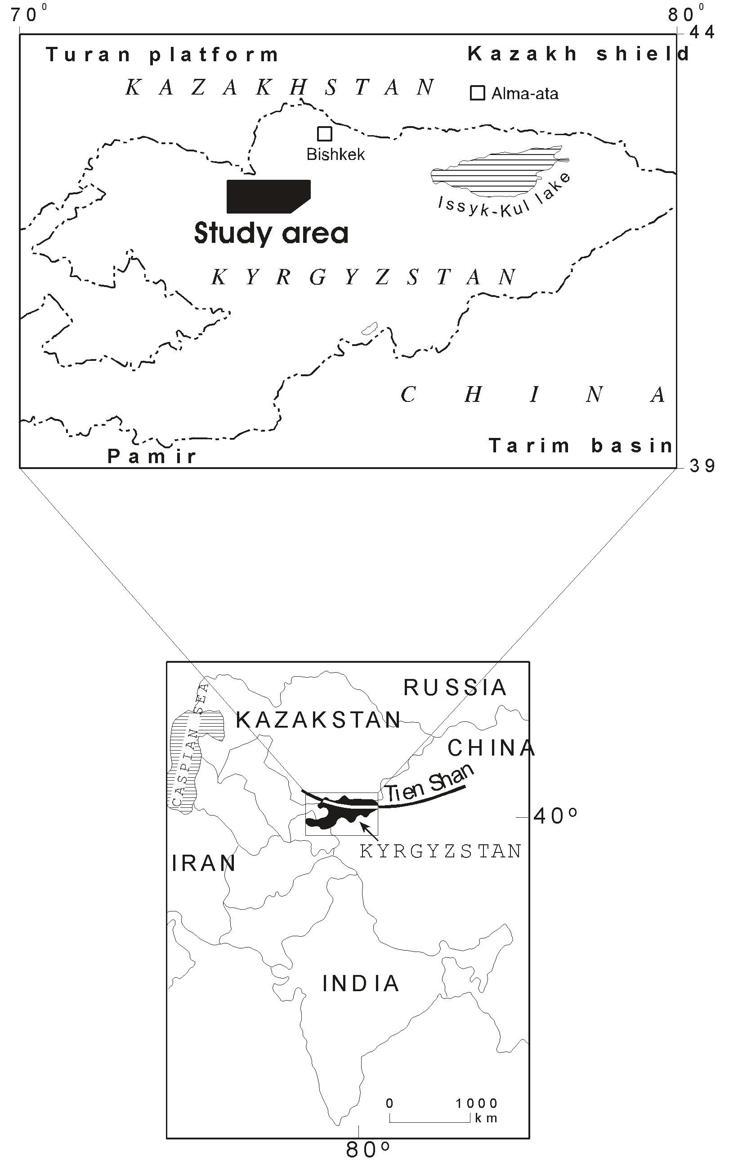
Fig. 1: Location of the Tien Shan belt and the Suusamyr valley.

Suusamyr earthquake occurred in the zone of Aramsu Neotectonic border fault tilted southward. It separates the Aramsu uplift (in the south) and the Suusamyr depression (in the north) as it is shown in the Fig. 2. The last one is surrounded by the Kyrgyz and Talas uplifts growing from the beginning of Neotectonic time. Their average elevations are about 4,200 m. The Kyrgyz and Talas ranges are thrusted onto Suusamyr depression along the zone of Karakol fault tilted northward.

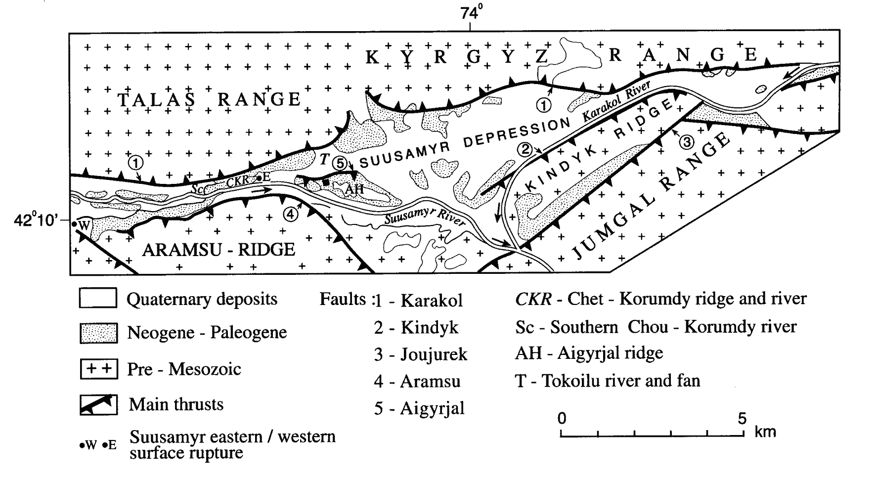

Fig. 2: Geological map of the Suusamyr valley. (Modified after Korjenkov et al., 1999)

Aramsu anticline-like uplift (maximum elevation is up to 3900 m) has steep and short northern limb, and gentle and long southern limb. This ridge represents an intradepressional uplift which has divided (in Neogene time) the depression into Suusamyr and Aramsu valleys.
Aramsu syncline-like depression has gentle northern limb and steep southern limb. In the south it is limited by Suusamyr-Too uplift growing from the beginning of Neotectonic time. The last one is thrusted to the north onto Aramsu depression along the Pre-Suusamyr fault tilted southward. Maximum elevation of the Suusamyr-Too range is 4,100 m. The range has also tectonic contact with Toluk depression in the south along the Northern-Toluk fault tilted northward.
During the Quaternary Aigyrjal and Chet-Korumdy intradepressional central uplifts were formed in the Suusamyr depression. Like Aramsu uplift they have southern gentle and northern steep limbs. Their northern limbs are broken by faults tilted southward. Maximum elevations of these structures are up to 2,600 m.
Thus, such uplifts as (from the north to south) Kyrgyz, Talas, Suusamyr-Too ones have been growing since beginning of Neotectonic time; Aramsu uplift was formed in Neogene; and Aigyrjal and Chet-Korumdy ones were formed in Quaternary time. Therefore these structures interact as a part of mountain system and have been consistently involved into structural rebuilding of the region. These structures are not only of different ages, but also of different scale. If at the beginning of Neotectonic epoch concentrators of the tectonic stresses and deformations were structures of the 1st order (such as Talas uplift and Suusamyr depression), later there was occurred redistribution of part of the stress and strain to the structures of lower orders forming till present. This process is reflected in distribution of seismic deformations.

3 Surface deformations formed during Suusamyr Earthquake of 1992
One of the founders of seismogeology V.P.Solonenko (1973) divided the great variety of residual deformations of the Earth crust into three large categories: seismotectonic, seismogravitation and gravitation-seismotectonic (transitional category). After field study of seismic deformations formed during the earthquake mentioned above (Korjenkov and Omuraliev, 1993, Korjenkov, 1996, Bogachkin et al., 1997, Ghose et al., 1997) the Map of Seismic Deformations of 1:100,000 scale (Fig. 3) was composed. The field data allowed revealing the additional category - seismoinertion one. In this paper we will examine only two types of deformations: seismogravitation and gravitation-seismotectonic (transitional category).

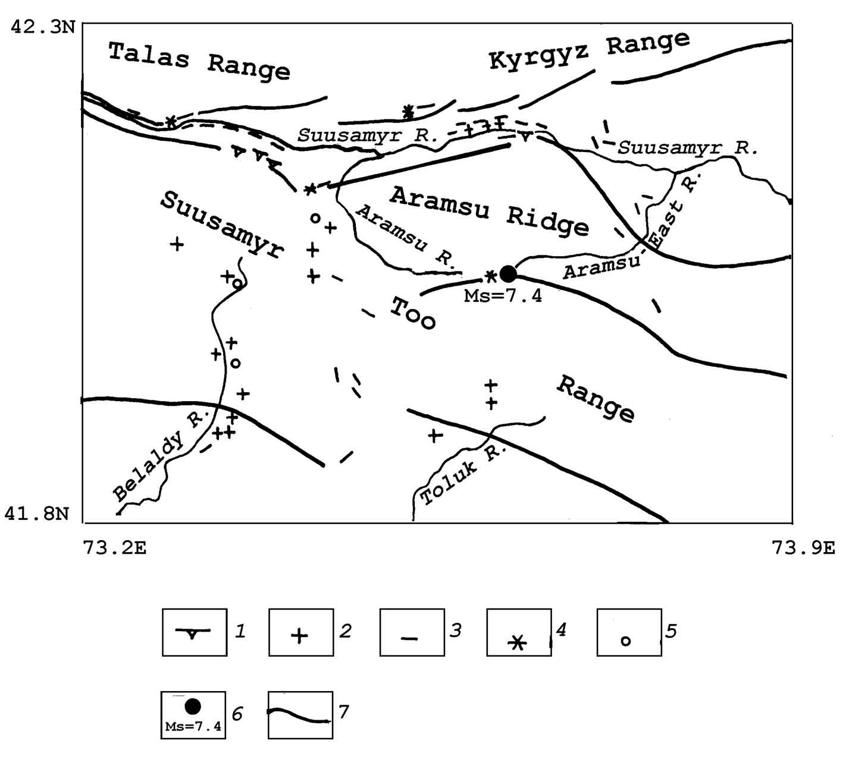

Fig. 3. Map of seismic deformations caused by Suusamyr earthquake (composed by M. Omuraliev, A. M. Korjenkov and E. Mamyrov in 1996). 1 - fault scarps, 2 - rockfalls and landslides, 3 - gravitation cracks, 4 - mud eruptions, 5 - places of shooting out (mining bursts) of rock blocks, 6 - epicenter of the earthquake, 7 - zones of Neotectonic border faults.

3.1 Intermediate type of seismogenic features

Gravitation-seismotectonic deformations were formed in a zone of maximum shaking of Suusamyr earthquake, and can be clearly observed in Chet-Korumdy ridge (on the left slope of the Suusamyr river valley). Here, the watershed area of the ridge is broken by a series of grabens of EW strike (Fig. 4a). The grabens are converging, diverging and dividing into several lines forming the right en-echelon pattern. Vertical displacement along the grabens is 1-2 m. Sometimes, there are horsts within large grabens. The width of such grabens is from 1-2 m up to 10-20 m. Two-meter exposure of rupture plane of the graben demonstrates brown loam soil overlapping sandy-clayey material with pebbles.

A 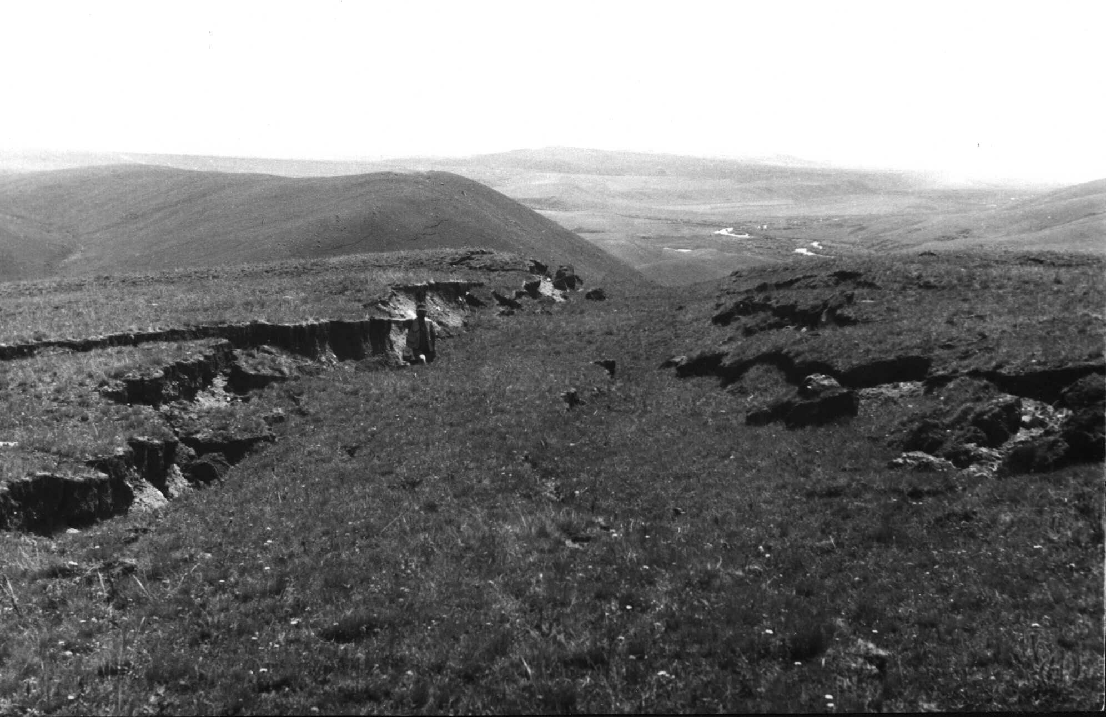
B 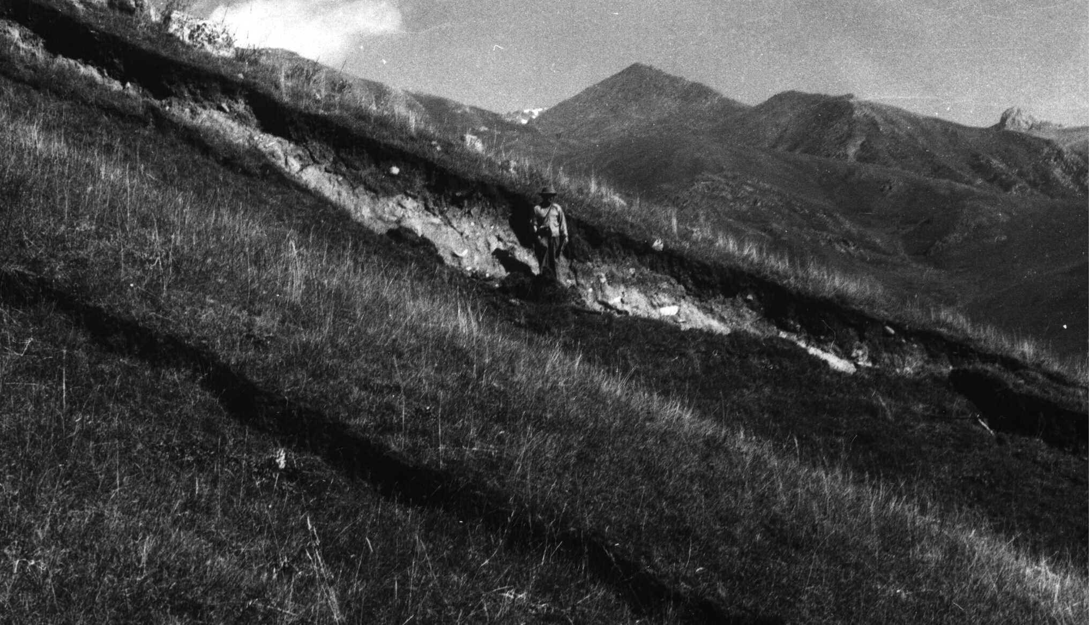

Fig. 4. Seismic deformations of intermediate type within the Chet-Korumdy ridge. A - Grabens on the watershed part of the ridge, B - wedges on the southern slope of the Chet-Korumdy ridge. Photographs of 1992(A) and 1993(B) by A. Korjenkov.
Lower the watershed area of Chet-Korumdy ridge described above, one can observe gravitation-seismotectonic wedges in the slope of the ridge (Fig. 4B) - future planes of the landslides. Morphologically they look like the slump-planes. The length of one of the wedges is about 100 m, and all the zone of the wedges stretches up to 2-3 km. In map view, the wedges look like arch-forms but, generally, they have EW trend. Sometimes the wedges are echelon-like, and sometimes they continue after short interruption. There are three zones of these wedges, and they are located on the distance of 40 m approximately from each other.

3.2 Seismo-gravitation features
Wide spectrum of seismo-gravitation deformations was abundant on the territory of Suusamyr depression and range. They are different types of displacement of rocks and grounds: sagging mountain slopes, rockfalls, landslides, ground avalanches and flows, mud/debris flows, and also great variety of gravitation cracks. For example, a series of the cracks with the depth of 50-60 cm and width up to 20-30 cm was formed in the zone of Karakol border fault at place of tectonic contact of the Talas uplift and Suusamyr depression. Fractures of the thrust and underthrust type are often associated with the fault and located in a soil-ground layer down the slope. The length of a single fracture is up to first tens of meters in Balyktysu-Kaziar interfluve. They have 230° strike azimuth. The depth of the fractures is up to 2 m; their bottoms were covered by water after the earthquake. Since the cracks described above are located in the zone of the border fault, one can observe appearance of ground water and outpouring of springs here. Along the slope in 12 meters below the cracks there was found a turf swell of compression with thrusting of soil layer up and down (underthrusting). The horizontal displacement is 30-40 cm.
The Karakol border fault has complicated structure in the region: it consists of ruptures breaking the structure of Late-Pleistocene-Holocene alluvial fan. Apparently, there is a series of four ruptures in the form of scarps. The rupture lines are marked by change of vegetation, appearance of springs and swampy lots. The ruptures have ENE strike and are located on the average distance of 100 m from each other.
The largest rockfall broke a part of the watershed on the left slope of the Southern-Jalpaksu river valley (the upper Belaldy River) as it is visible in Fig. 5. The massif of basement rocks fell down into the river valley, then jumped up on the opposite slope and rushed down along the valley for the distance about 1,000 m. The rockfall body covered a shepherd's family and flock of sheep. Both the height and width of the scar is about 200 m (Fig. 5 a). There were fallen blocks of light coarse-grained granites with insertions of xenoliths (Fig. 5 b). Sizes of largest fragments are up to 10 x 10 x 15 m. Thickness of rockfall body is more than 100m, width is 500 m, and volume, apparently, is more than 50,000,000 m³. Body of the rockfall dammed partly the Jalpaksu River and formed two small lakes along the valley (Fig. 5 c). The square of their water surface was approximately 200-300 m² on September 7, 1992. In a year the water level increased enough to destroy the dam. Gradual destruction of the dam during the summer of 1993 was resulted in a long-term mud- and debris-flow (Fig. 5 d) which caused a lot of damage for infrastructure of Toktogul region.

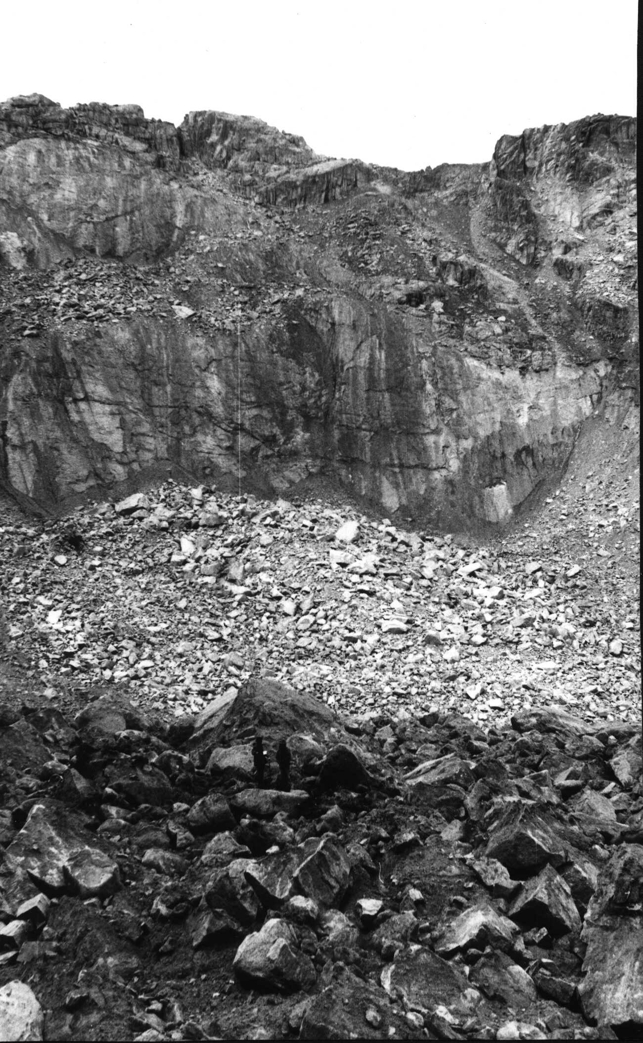  (A) | 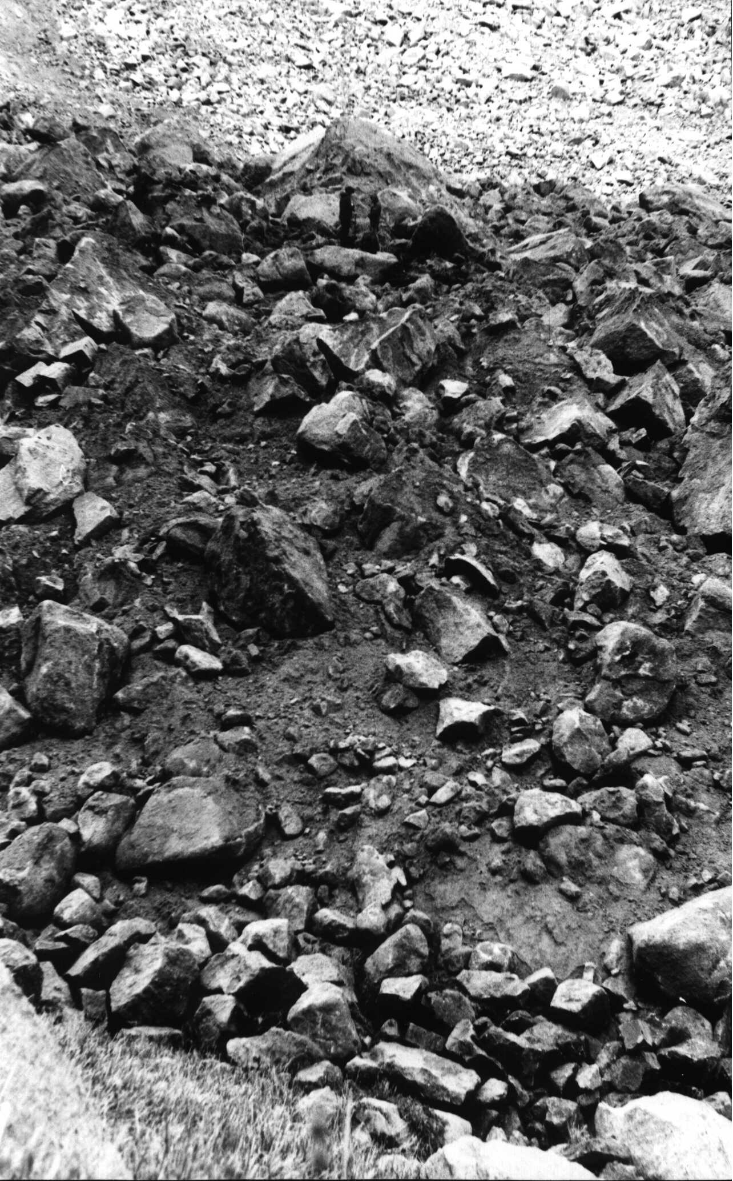  (B)
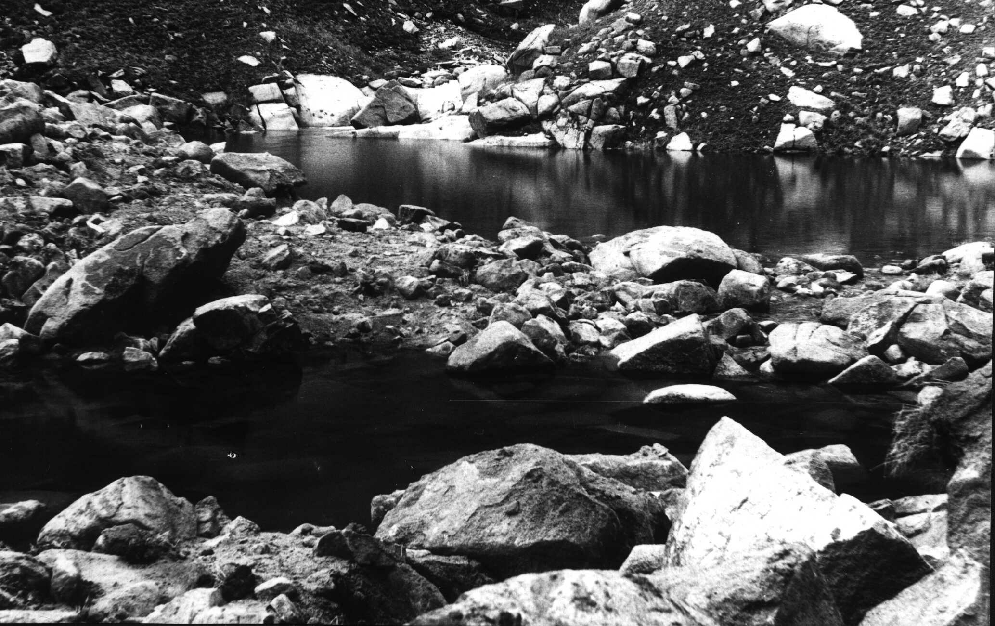  (C) | 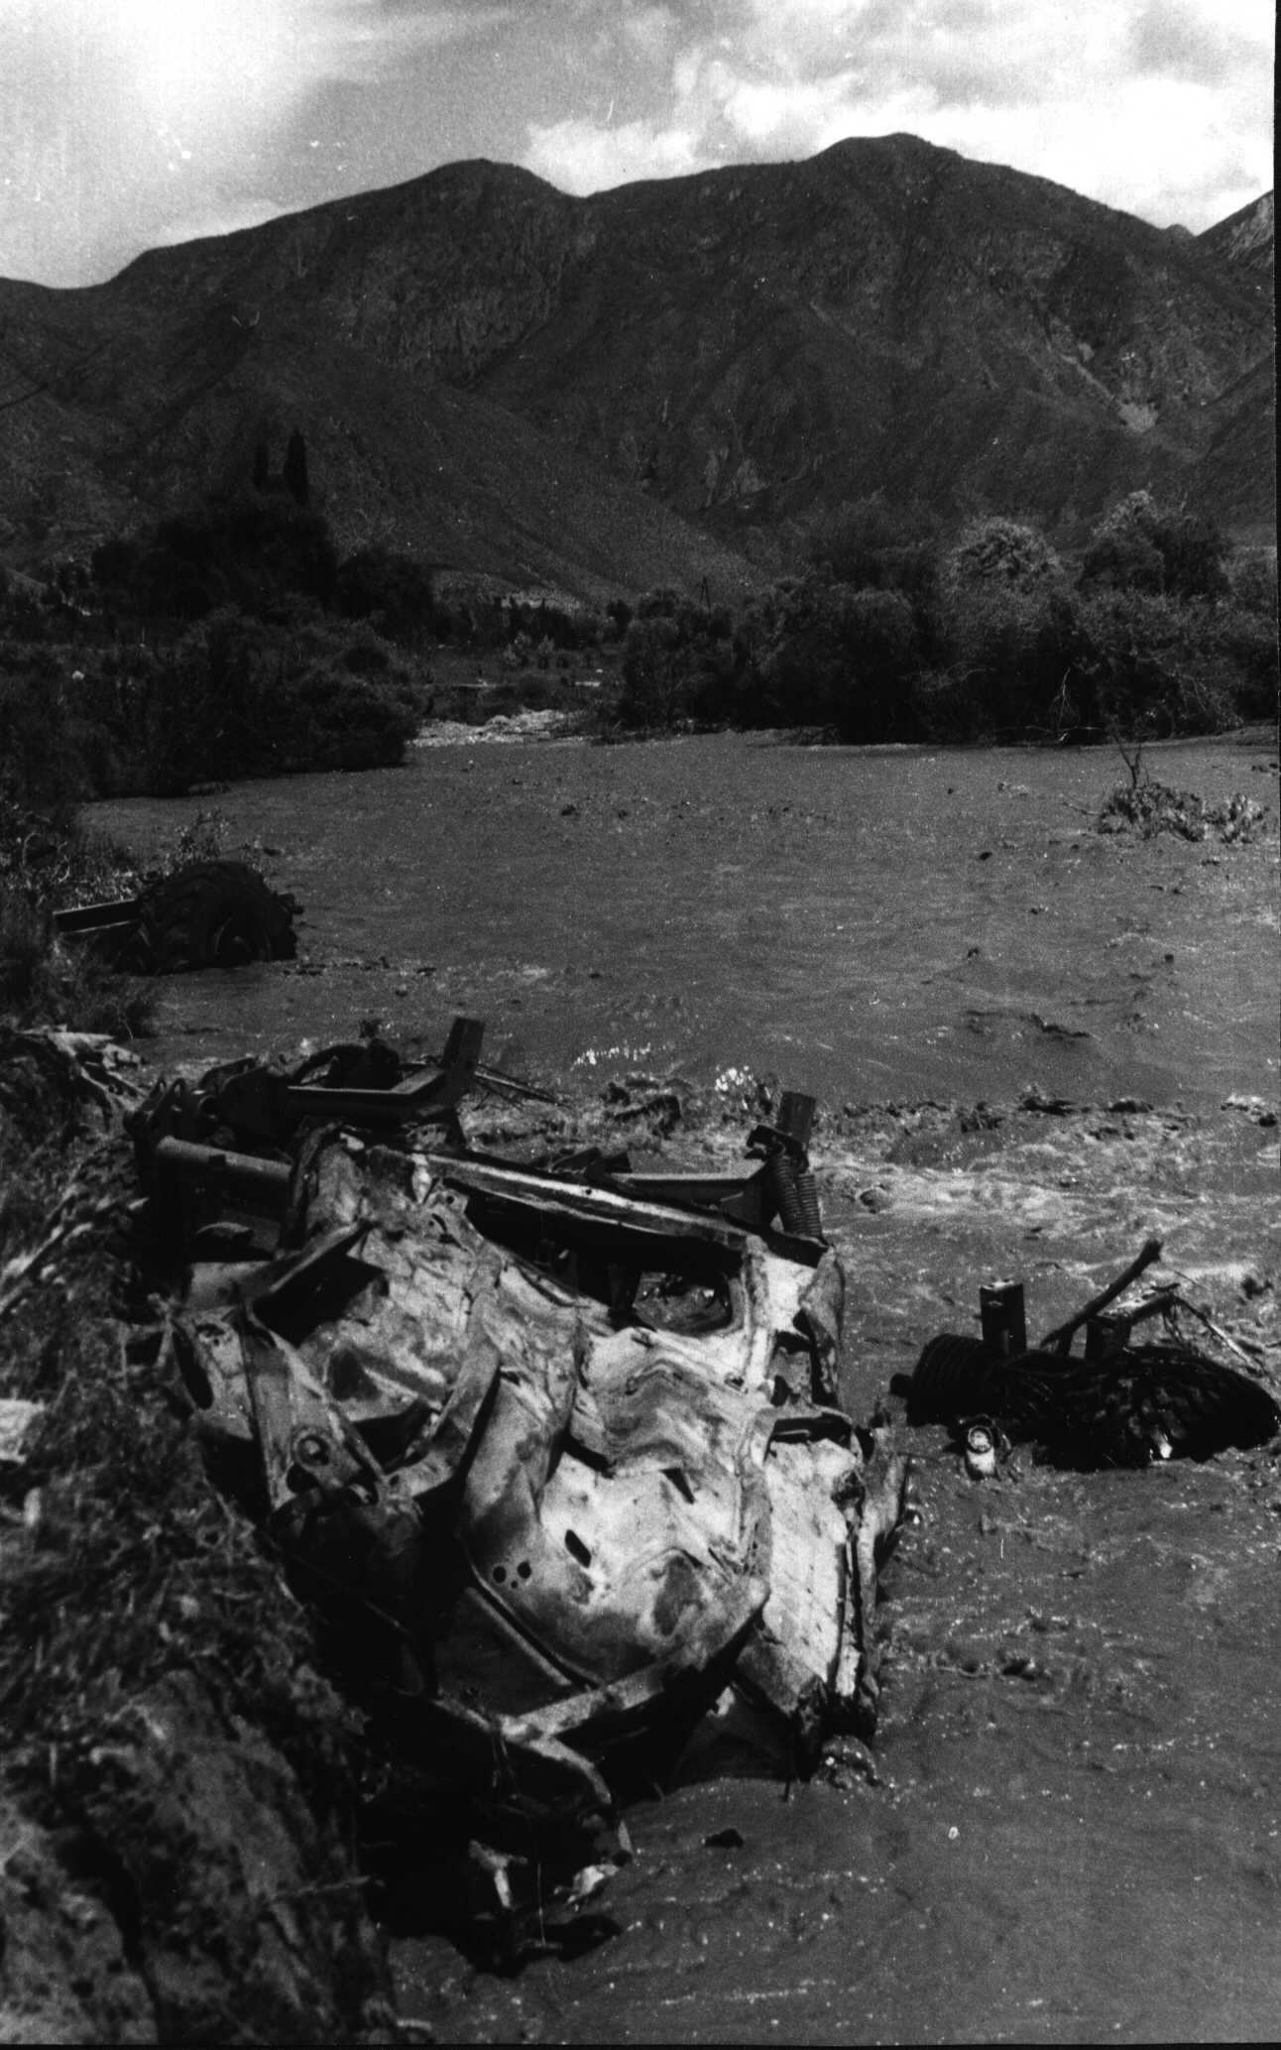 (D)
Fig. 5. Seismic rockfall in granites in the upper Belaldy river valley.
A - scar;
B - rockfall body jumped on the opposite slope of the river valley;
C - small lakes formed due to damming of the Belaldy river;
D - mud flow formed in result of break of the dam in a year after the earthquake. Photographs of 1992(A-C) and 1993(D) by A. Korjenkov

Generally, rolling stones during the earthquake may be also attributed to seismo-gravitation deformations. Failures, large rolling stones took place on the southern slope of the Talas range (Korumdy river valley, the upper part of Suusamyr river valley and other places), on the slopes of the valleys of Chichkan and Ters rivers and other. The size of separate displaced blocks reaches the first meters. For example, a granite non-rounded block fall down the watershed part along the mountain slope of Talas Range and stopped on the surface of Holocene alluvial terrace (Fig. 6) of the Suusamyr River. The size of the block is 2,5 x 2,5 x 2,0 m. Rolling down the slope the granite block “jumped up” every time remaining deep (up to 0,5 m) moulds in the soil at the distance of the first meters from each other. There was often observed deviation of trajectories of the rolling stones from the straight line. The deviation is apparently related to the relief.

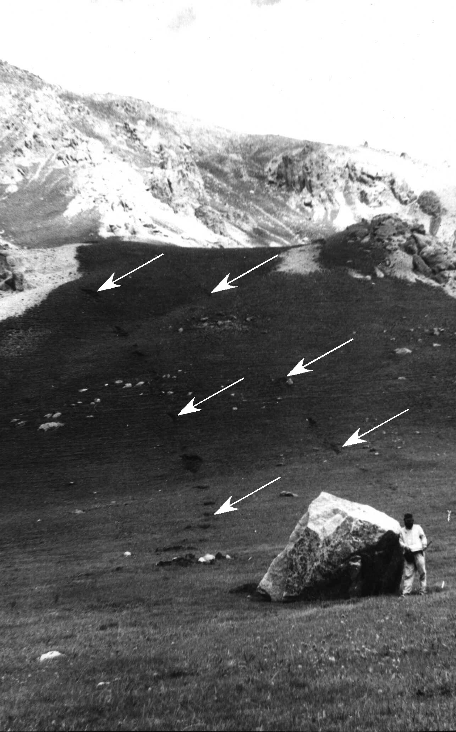

Fig. 6. Rolling stones in the upper Suusamyr river valley.
Photograph of 1993 by A. Korjenkov

Collapsing of the steep cuesta scarp composed by Paleozoic sandstone occurred in 800 meters northward of the Iribulak-Aramsu pass. The width of the fallen mass is 50 m, length is 100 m, average thickness is about 1 m, and therefore, the volume of the body doesn’t exceed 5,000 m³. Similar rolling stones on the steep cuesta scarp composed by red sandstone were observed in 2 km south-eastward of that one mentioned above.
Large granite rolling stones are found on the left slope of the Belaldy river valley, in 2.5 km southward of the Boorteke Pass. The width of the scar is 50 m, height is 70 m. The upper part of the scar coincides with the watershed. The length of the rolling stone body is 150 m, width is 50 m, and average thickness is 2-5 m. However, separate blocks in the rolling stone body were of bigger sizes. One of such blocks fallen into the Belaldy river channel has the size 5 x 10 x 10 m, weight is more than one thousand tons. White coarse-grained granites with inclusions of xenoliths were ruined. Similar fallings of separates blocks and rolling stones of smaller size are often observed on the both slopes of the Belaldy river valley.
Landslides occurred on the southern slope of the Chet-Korumdy ridge (Fig. 7). The ridge is composed by Neogene sandstone with interlayers of clays overlapped by Quaternary alluvial deposits. Three landslides are located at the different altitude levels. The slope composed by Middle Pleistocene alluvium collapsed. Frontal parts of the disintegrated rock mass slid down to “Osh-Bishkek” highway. Thickness of the moved mixed rocks is 3-8 m (5 m in average). Well preserved fragments of soil layer are located on the surface of the landslide bodies. This fact indicates short displacement of the slid rocks. Width and length of the seismic landslides reach 100 m, the scar is of the same width, and heights are up to 10-20 m.

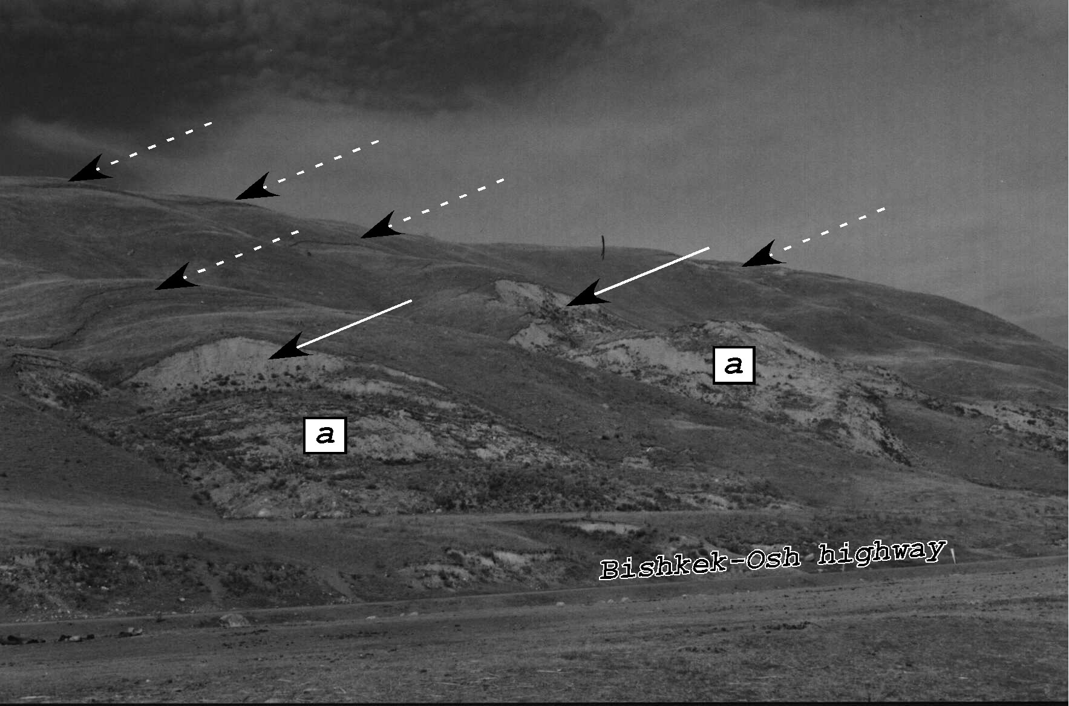
Fig. 7. Landslides on the southern slope of Chet-Korumdy ridge. a -landslide bodies, solid arrows - landslide scars, dashed arrows - gravitation wedges (future scars of landslides). Photograph of 1997 by A. Korjenkov

Lower the described landslides there are small soil thrusts of compression (tens of centimeters) on the slope. These thrusts were formed as a result of pressure of landslide masses on the soil layer. Besides the movement of soil layer down the slope, there are some cases of underthrusting and thrusting of a lower layer upwards. Except for the thrusts and underthrusts, there is a number of gravitation cracks (lengths of hundreds meters) on the surface of the terrace which are mostly parallel to the terrace edge. However, there are double-side grabens of usual depth up to 1,5 m. Parameters of the largest one are: width is up to 5 m, depth is up to 2,5 m, width of the opening is 0,2-1,3 m.
New landslides and frequent gravitation cracks were formed on paleoseismic rockfalls and paleoseismic landslides on the left slope of the upper Suusamyr river valley. Usually the upper part of soil layer is broken by cracks. The length of the cracked lot is up to 100 m, width is up to 10 m, and the number of cracks is up to 10. The depth of a single crack is up to 1 m, value of subsidence is 0,5 m, width of the opening is up to 0.5 m. Cracks are parallel to the slope. Besides the cracks there were also observed small rolling stones.
On the southern slope of Chet-Korumdy ridge (near 166 kilometer-post of “Bishkek-Osh” highway) there are three age generations of seismic deformations (Fig. 8). Two of them are old ones. Upslope facing scarps were formed first. Then they were partly destroyed by the scar of an old landslide. The landslide caused by Suusamyr earthquake superimposes these ancient seismic features.

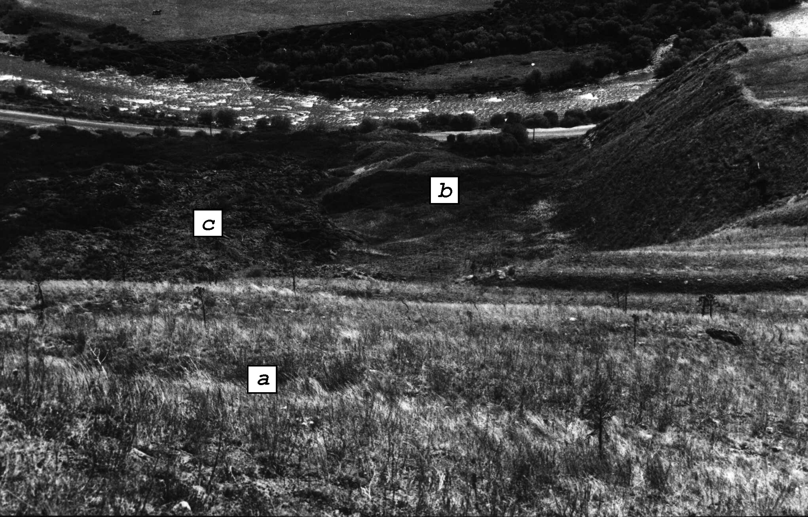

Fig. 8. Three different-age generations of seismic deformations on the southern slope of Chet-Korumdy ridge: a - ancient upslope facing scarps (earliest generation), b - body of ancient landslide (second generation), c - body of the landslide formed during Suusamyr earthquake. Photograph of 1992 by A. Korjenkov

Seismo-gravitation deformations also include ground displacements down the slope: earth avalanches, flows and mud flows (sels). A mud flow occurred on the left slope of Belaldy river valley in the first days after the earthquake because of damming the channels of temporary springs.
Description of the earth avalanche is given as an example: it was observed in 0.7 km south-eastward of the Archaly mountain. Here, separation of the soil layer of small thickness (up to 1 m) and its transportation down the slope occurred along the spring valley above “Bishkek-Osh” highway.
In general, the seismic features (deformations) of Suusamyr earthquake described above are distributed in limits of (from the north to the south): Suusamyr, Aramsu and Toluk depressions; Kyrgyz, Talas, Chet-Korumdy, Aramsu, Suusamyr-Too uplifts. They are especially frequent in segments of the zones of Karakol, Pre-Suusamyr, Aramsu and Northern-Toluk border faults in their hanging limbs. Area of distribution of these deformations extends on 60-65 km and has the width of 35-40 km that is 1850 km². This region coincides with the area of aftershocks of Suusamyr earthquake. The aftershock activity of the earthquake continues more then five years that is a rare phenomenon.

4 Paleoseismic deformations in the Suusamyr depression
Study of epicentral zones of strong historical earthquakes in Asia (Solonenko, 1973, 1975, 1976; Khromovskikh, Nikonov, 1984; Nikonov, 1988; Omuraliev, 1988; Omuraliev and Charimov, 1989, Korjenkov and Charimov, 1993, Korjenkov et al., 1994, Korjenkov et. al, 1999, Korjenkov, 1999 and others) allow the following conclusions:

- Seismic deformations can be divided into three main groups: seismic faults (seismotectonic), seismo-gravitation and intermediate.
- Residual seismic deformations of the same age concentrate along the certain segments of the fault zone.
- Surface faults (scarps, upslope facing scarps and others) occur in the mezoseismal zone of strong earthquakes (seismic intensity I=9 and higher, MSK-64 Scale). They are mainly co-seismic and impulse ones.
- Seismo-gravitation seismic features occur at the seismic intensity I=7 and higher, but large seismic rockfalls of basement rocks occur at the seismic intensity I=9 and higher.
- Recurrence of strong earthquakes is reflected in superposition of seismic deformations of different ages.
- These conclusions were a basis for the study of paleoseismic deformations and determination of parameters of ancient strong earthquakes.
- Detailed study, mapping of paleoseismic deformations and also interpretation of air-photographs have been conducted within the described region (Fig. 9). There were found numerous traces of paleo-earthquakes:
- Fault scarps, upslope facing scarps and ruptures
- Rockfalls and landslides
- Formations of “broken plate” representing by combination of upslope facing scarps and ruptures.

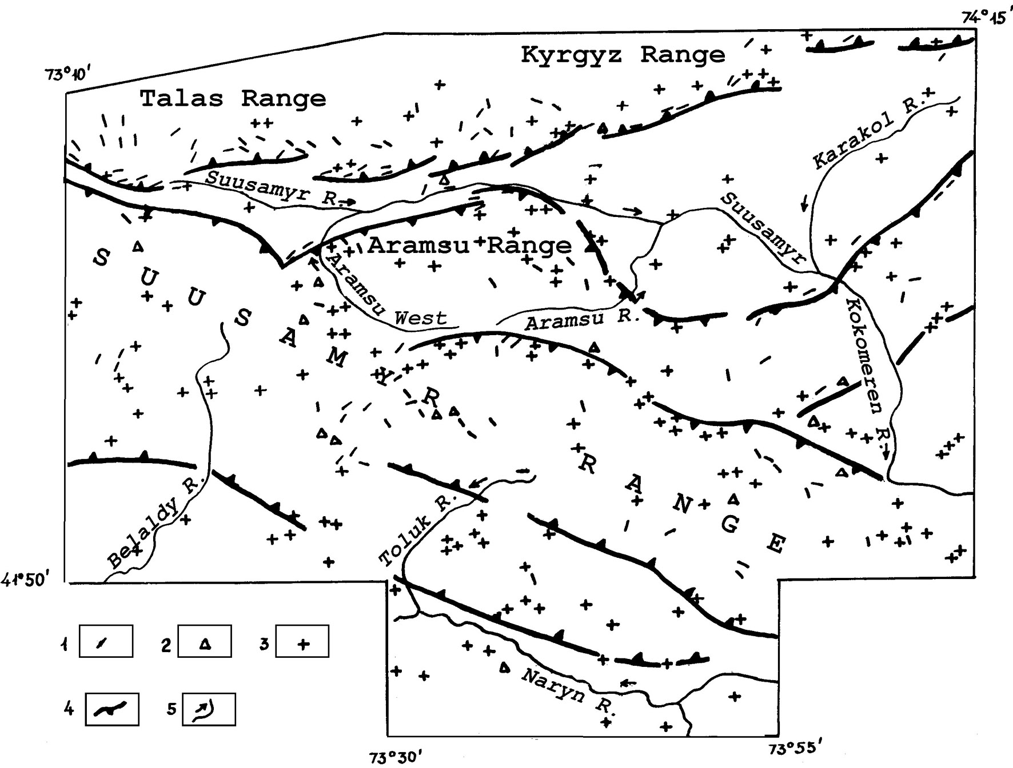
Fig. 9. Map of paleoseismic deformations within the area of Suusamyr earthquake (Composed by M. Omuraliev, A. M. Korjenkov and E. Mamyrov in 1996). 1 - Upslope facing scarps, 2 - structures of „broken plate“, 3 - rockfalls and landslides, 4 - zones of Neotectonic border faults, 5 -arrows showing river flows.

These seismic deformations are concentrated to active Neotectonic border faults, especially to their hanging limbs (See Fig. 9). The concentrations of paleoseismic deformations seem to be epicenters of strong paleo-earthquakes.
Thus, the first locality of seismic features is in the south of the Otmek pass in western Talas uplift. There are three large scarps of maximum height up to 1.5 m and upslope facing scarps of the length up to 2.5 km. They have sub-meridional and sub-latitudinal strikes. The last ones are developed in the zone of Karakol border fault or close to it in its hanging northern limb. Moreover, there is a large rockfall in granites close to this fault zone. The length of scar is about 1,000 m and height is 90 m. The rockfall body extends on the distance of 1,500 m, and its width is up to 600 m.
The second locality of paleoseismic deformations is in the lower Chon-Korumdy river valley (left tributary of the Suusamyr River). The Chon-Korumdy River makes a band in its middle part in front of the growing young Chet-Korumdy ridge. There is an abandoned dry consequent channel of former river bed crossing the ridge. This diversion of the Chon-Korumdy River in Holocene is caused by formation of a fault scarp of sub-latitudinal strike. The length of the Holocene scarp is about 2 km and it is located in the fault zone which limits the Chet-Korumdy intradepressional uplift in the north. The scarp dammed the river causing sharp bend of its channel (Korjenkov et al., 1999, 2003).
There is also large rockfall in granites formed in the hanging northern limb of the Karakol fault in the described locality. The length of the scar is up to 1.500 m, height is 120 m. The rockfall body has the length of 1,700 m, and average width of 1,000 m. A fresh landslide was formed in the rockfall body that testifies co-existence of two age generations of paleoseismic deformations here.
The third locality of seismic deformations is in the Tokoilu river valley (left tributary of the Suusamyr River). There is a Holocene fault scarp formed along the fault zone which limits the Aigyrjal intradepression uplift. The length of the scarp is 3.5 km, and height is more than 2 m. This scarp dammed the Tokoilu river channel causing a sharp bend in front of the seismic scarp (Korjenkov et al., 1999, 2003).
The forth locality of seismic deformations is in the Altygana (right tributary of the Suusamyr river) and Aramsu-Eastern river valleys. There was formed a series of sub-parallel upslope facing scarps of 300-400 m length on the left slope of the upper Altygana river valley in the hanging wall of Aramsu border fault that is a zone of 400-500 m width. The series of scarps is close to the fault zone. In the south of it there is a large landslide developed in soft grounds (fluvial-glacial deposits). The length of the scar is 4,500 m; height is 30-40 m. The length of the landslide body is 3.5 km. The landslide was formed on the southern hanging limb of Aramsu border fault in 5 km to the south of the fault zone. In the south of the landslide scar there was formed an upslope facing scarp of sub-latitudinal strike of 1,500 m length and 10 m depth.
A large rockfall was formed in granites on the left slope of the middle Aramsu-Eastern river valley along the Aramsu fault. The length of the scar is 2,000 m, height is 200 m. The rockfall body extends on the distance of 1,500 m.
The fifth locality of seismic deformations occupies Tuzduksu, Belaldy and Kashkasu river basins. It is located in the northern hanging limb of the Northern-Toluk Neotectonic border fault in 9-10 km northward. Wide development of “broken plate” deformations with the diameter of 1,500 m is observed in the Tuzduksu river valley. This structure consists of upslope facing scarps (of the length up to 1,500 m) and ruptures.
There are large granite rockfalls in the middle Belaldy and Kashkasu river valleys. The length of the scar of one of the rockfalls in Belaldy river valley is up to 1,000 m, height is 200 m. The rockfall body jumped to the opposite side of the river valley and extends on the distance up to 2,000 m downward the valley. Its width is up to 800 m. There is a developed river channel and Holocene alluvial terraces in the rockfall body.
The sixth locality of paleoseismic deformations occupies the eastern part of the Suukdebe Mountains and adjusting part of the Naryn river valley. Here there is a sub-meridional upslope facing scarp of 2000 m length (Fig. 10). In the east of it there was formed a large rockfall in the northern hanging limb of the Pre-Suukdebe Neotectonic border fault in 5 km northward of its zone. The scar has the length of 5,000 m, height of 160 m. The rockfall body extends on 3,500 m with the width of 1,500 m. The other large seismic rockfall is located on the left slope of the Naryn river valley. It was formed in basement rocks of the southern hanging limb of the fault. The length of the scar is 3,000 m, height is 260 m. The rockfall body extends on the distance of 2,000 m; its width is 1,000 m.

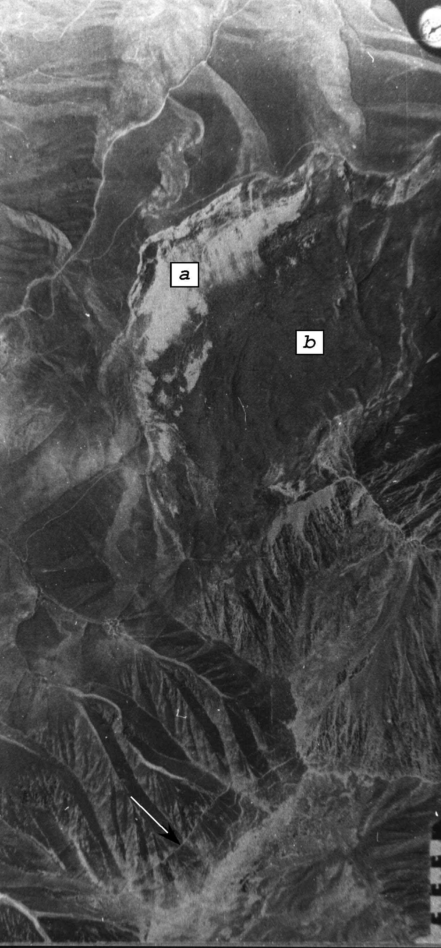

Fig. 10. Paleoseismic deformations of the Suukdebe uplift. Upslope facing scarps are shown by the arrow in the left side of the photo. The large rockfall is in the center of the photo. Arch-like light patch on the photo is a detachment plane of the rockfall.

Thus, there were six strong paleo-earthquakes within the region. The epicenter of Suusamyr earthquake is located between localities of paleo-seismic deformations formed during strong ancient earthquakes, that is this epicentral zone filled a seismic gap between the areas of strong ancient earthquakes.

5 Computer modeling of stress-strain state of landslide massifs
Reliable prognosis of landslide processes in seismically active zones is possible only at complex approach to the problem solution. This approach supposes use of all available methods and means: field observations, permanent automatic monitoring of displacements, geophysical investigations, digital modeling of stress state of the massif, space technologies.
Nowadays, digital modeling of deformations of rock massifs is widely developed in engineering practice. Great quantity of the program products realizing different methods of modeling of stress field has been elaborated. The problem can be solved completely at use of results of permanent observations in complex with digital calculations of stress-strain state of rocks. This approach allows counting all the main factors effecting onto stability of the mountain slopes:
- real structure of rock massif;
- rock anisotropy;
- distribution of pore pressure variations;
- influence of natural stresses, including tectonic forces.
Digital modeling allows conduction of preliminary assessment of the state of the landslide massif before establishing of expensive equipment for permanent automatic monitoring of displacements. When conducting the observation on the landslide the data of displacements allow more precise definition of the parameters of geomechanical model which is used in digital modeling. Thus, field observations and computer modeling supplement each other.
The program package “Stress” was elaborated on the basis of calculations by the method of final elements at the Laboratory of Geoinformatics of the Kyrgyz-Russian Slavic University, Kyrgyzstan. The program complex is intended for assessment of stability of different rock massifs: slopes of quarries, natural slopes, mining tails, dams of reservoirs etc. When elaborating the system, the emphasize was made on providing of exploitation simplicity of the system of final-element modeling. It is achieved by automatic formation of final-element network and setting of boundary conditions which are maximally informative for result representation. The complex of geomechanical models describing behavior of main types of rocks is realized in the “Stress” system. The complex allows taking into consideration enormous variety of peculiarities of rocks and character of their destruction. Determination of a line of probable sliding and calculation of stability coefficient along it is possible using the program package.
Adequacy of geomechanical models and program realization of algorithms was tested by field observations, physical experiments and results of calculations using analogous programs. Elaborators have long-time experience in practical use of “Stress” complex in scientific and engineering work.
For instance, the stress field of “Isolit 2” landslide (Mayluu-Suu town, Kyrgyzstan) was calculated using the “Stress” program package. Results of the calculations are presented in Fig. 11 as a zone of plastic deformations and in Fig. 12 by isolines of tangent stress. Revealed existence of the zones of plastic deformations testifies on non-stable state of rock massif composing the landslide. High gradient of tangent stresses in the zone of movement indicates a critical level of massif condition; real thickness of the landslide coincides with calculated sizes of viscosity zone. The calculated results are confirmed by the field observations on the landslide.

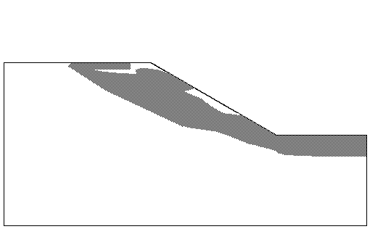
Fig. 11. Zones of plastic deformations

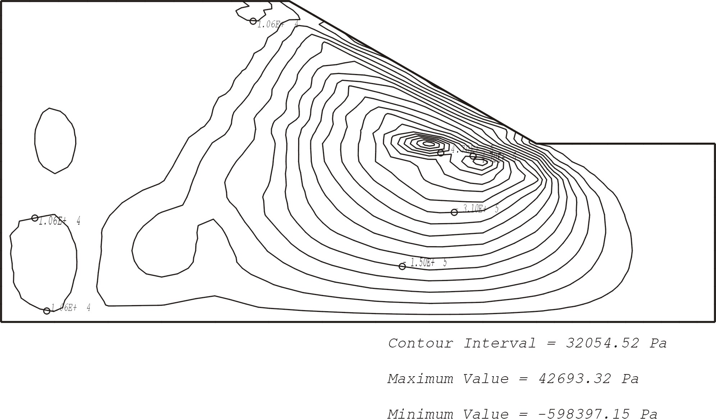
Fig. 12. Isolines of tangent stress.

Thus, the proposing method and “Stress” program package can be utilized as components of landslide mapping on the basis of space technologies and prognosis of catastrophic collapses of rock masses under effect of seismic and climatic factors.

6 Discussion and conclusion
Three main groups of the seismic deformations were formed at the strong Suusamyr earthquake (1992): seismotectonic, seismogravitation and intermediate ones.
The area of distribution of seismic deformations includes a number of ranges and depressions of the Tien Shan: Kyrgyz, Talas, Suusamyr-Too, Aramsu uplifts, and Suusamyr, Aramsu and Toluk depressions. The deformations concentrate near the subparallel zones of Neotectonic border faults: Pre-Suusamyr, Aramsu, Karakol and Northern-Toluk locating on the distance about 15 km from each other. These tectonic structures were responsible for Suusamyr earthquake of 1992. The area of seismic deformations coincides with the area of aftershocks of the earthquake.
Seismic deformations and also paleo-seismic ones are concentrated near the zones of border faults in their hanging limbs and steep limbs of anticline-like uplifts. At least three age generations of seismic deformations were found within one locality: two of them are consequence of paleo-earthquakes, and the last one is a result of Suusamyr earthquake. This earthquake occurred after more than 2,000 years of previous one (Korjenkov et al., 1999, 2003), and its focus zone filled a seismic gap between the areas of strong paleo-earthquakes.
The Map of Seismic Zoning of Kyrgyzstan of 1977 (Dzhanuzakov et al., 1997) demonstrates the intensity I = VII-VIII of probable earthquakes in the Suusamyr depression. However, the 1992 Suusamyr earthquake manifested I = IX-X of seismic destructions. The new Map of Seismic Zoning was proposed in 1996 after the event. The new map demonstrates the intensity I=9 for the Suusamyr valley and surrounding ranges. So, should we wait for another strong earthquake, severe destructions and numerous victims in order to correct the values of seismic intensity for other parts of Kyrgyzstan? The answer is no. There are numerous evidences of paleo-gravitational deformations on the territory of the Suusamyr depression, as well as on the territory of whole Tien Shan. Their careful mapping with use of detailed satellite imagery will help to create the data bank - catalog of gravitational deformations for Kyrgyzstan. This database will be a basis for re-assessment of seismic and landslide hazard in the Kyrgyz Republic.

7 Directions of future investigations

7.1 Revealing the paleoseismic deformations using satellite imagery
The described recent seismic-gravitation deformations serve to be the test structures for the following revealing and mapping of paleoseismic deformations formed at strong ancient earthquakes using the satellite images. Obtained data will fulfill the lack of materials which are necessary for precise assessment of seismic and landslide hazard and risk on the Kyrgyzstan territory.

7.2 Computer modeling of stress-strain state of landslide massifs
Computer modeling of the landslide processes according to the examples of known seismogenic rock avalanches and landslides in the Suusamyr valley will allow us better understanding of the mechanism of landslide formation and spatial prognosis of future rock avalanches and landslides.

Acknowledgements
Field data for this paper were obtained together with D. Bowman, T. Charimov, N. Porat and M. Yunusaliev, in 1992-1998. Authors thank them for their help in the field and following fruitful discussion of the materials. I. Povolotskaya has significantly helped with correction of English of this paper. The work on this paper became available due to financial support of US CRDF (grant YG2-2542-B1-03).

References
Abdrakhmatov, K. E., A.M. Korjenkov, I. N. Lemzin and O.K. Chedia. 1994. Dzhumgal intermontane depression in Neotectonic structure of the Tien Shan (in Russian). - In: (Ed. O.K. Chedia), Tien Shan in epoch of Neotectonic mountaineering. Bishkek. Ilim Publishers. Pp. 62-86.
Bogachkin B. M., A. M. Korzhenkov, E. Mamyrov, Yu. V. Nechaev, M. Omuraliev, A. E. Petrosyan, K. G. Pletnyov, E. A. Rogozhin, and T. A. Charimov. 1997. The Structure of 1992 Susamyr Earthquake Source Based on Its Geological and Seismological Manifestations. Izvestiya. Physics of the Solid Earth. Vol. 33, No. 11, pp. 867-882.
Chedia O.K., Abdrakhmatov K.E., Korzhenkov A.M., Lemzin I.N. 1998. Seismotectonic position of the Balasogum, north Tien Shan earthquake of the 15th century. Journal of Earthquake Prediction Research. Vol. 7. Pp. 289-299.
Dzhanuzakov, K., B. Iliasov, V. I. Knauf, V. G. Korolyov, E. V. Khristov, O. K. Chedia. 1977. Seismic Zoning of the Kirgiz SSR. - Frunze, Ilim Press, 56 p.
Ghose, S., R. J. Mellors, A.M. Korjenkov, M. W. Hamburger, T. L. Pavlis, G. L. Pavlis, M. Omuraliev, E. Mamyrov, and A. R. Muraliev. 1997. The Ms = 7.3 1992 Suusamyr, Kyrgyzstan earthquake in the Tien Shan: 2. Aftershock focal mechanisms and surface deformation. Bulletin of Seismologic Society of America. Vol. 87, No. 1, Feb. pp. 23-38.
Khromovskikh V.S., Nikonov A.A. 1984. Along the traces of strong earthquake. Moscow: Nauka Publishers. 144 pp. (In Russian).
Korjenkov, A.M. 1996. Forms of a Relief Formed During Strong Suusamyr Earthquake 1992 in Northern Tien Shan. - In: International Association of Seismology and Physics of the Earth Interior's Regional Assembly in Asia. Tangshan, China. Aug. 1-3. 1996. Abstracts. P. 216.
Korjenkov A. M. 1999. Morphostructure and seismicity of the Kochkor depression and its mountain surrounding (the northern Tien Shan) (in Russian). Proceedings of National Academy of Sciences, Kyrgyz Republic. No. 3-4, pp. 33-39.
Korjenkov A., Bowman, D., Haselton K., and Porat, N. 1999. Recent drainage diversions under thrusting conditions in the Suusamyr Valley, the Tien Shan Range, Kyrgyzstan. Isr. J. Earth Sci. Vol. 48. Pp. 63-79.
Korjenkov, A. M., D. Bowman, E. Mamyrov, M. Omuraliev, N. Porat. 2003. Diversions of the drainage network caused by recent tectonics in the Suusamyr depression, northern Tien Shan (in Russian). “Proceedings of Russian Geographic Society”. No. 2, pp. 49-61.
Korjenkov, A.M. and T. A. Charimov. 1993. Chonkurchak series of seismic deformations as an evidence of repeated seismic catastrophes near Bishkek city (in Russian) - In: (Ed. T. N. Yankevich) Actual Questions in Geology, Geophysics, and Seismology. Bishkek. Ilim Publishers. Pp. 7-14.
Korjenkov, A.M., I. N. Lemzin, A. B. Fortuna and O.K. Chedia. 1994. Southern-Talas Fault Zone in tie with its seismicity (in Russian). - In: (Ed. O.K. Chedia) Cenozoic Geology and Seismotectonics of the Tien Shan. Bishkek. Ilim Publishers. Pp. 56-85.
Korjenkov, A.M. and M. Omuraliev. Forms of relief formed during strong Suusamyr earthquake (1992) in the northern Tien Shan. (In Russian). - Geomorphologic Risk. II Lectures for Memory of N. A. Florensov. Nov. 1993. Irkutsk Geomorphologic Seminar. Abst. Irkutsk. Pp. 105-106.
Molnar P., Tapponier P. 1975. Cenozoic tectonics of Asia: Effects of continental collision. - In: Science. Vol. 189, No. 4201. Aug. 8. Pp. 419-426.
Molnar P., Tapponier P. 1977. The collision between India and Eurasia. - Scientific American. Vol. 236. No. 4. Pp. 30-41.
Nikonov A.A. 1988. Reconstruction of the main parameters of old large earthquakes in Soviet Central Asia using the paleoseismological methods. - In: Tectonophysics. Vol. 147. Pp. 297-312.
Omuraliev M. 1988. Seismotectonics of the Kirgiz SSR. 1:500,000 map. Tashkent Map Factory of GUGK USSR.
Omuraliev M. and T. Charimov. 1990. Seismic deformations and seismic hazard in the western part of northern Kirgizia. - Proceedings, Academy of Sciences, Kirgiz SSR. No. 4, p. 83-88.
Solonenko V.P. 1973. Paleo-seismogeology. - In: Physics of the Earth. No. 9. Pp. 3-16 (in Russian).
Solonenko V.P. 1975. Scale of seismic marks due to seismic deformations. - In: Seismic scale and methods of evaluation of seismic intensity. Moscow: Nauka Publishers. (In Russian).
Solonenko V.P. 1976. Seismically induced rockfalls and earth avalanches. - In: Geological regularity and mutual causality of development of landslides, rockfalls and debris-flows in mountain-folding areas: A basis of forecast and measures against them. Issue 2. Moscow: Moscow State University Publishers. (In Russian).

