Center for Integrating Analysis of Environmental Data and Models

A proposal for the Information Sciences/Information Technology component of the ASU Proposition 301

Management team: J Ramón Arrowsmith (Geological Sciences), Jana Hutchins (Information Technology), Laura Musacchio (School of Planning and Landscape Architecture), Jeremy Rowe (Information Technology), Elizabeth Wentz (Geography)

Investigators: Ronald Dorn (Geography), Robert M. Edsall (Geography), H. Joe Fernando (Mechanical and Aerospace Engineering), Huan Liu (Computer Science and Engineering), Charles Redman (Center for Environmental Studies and Anthropology), Stephen J. Reynolds (Geological Sciences), Nancy Selover (Office of Climatology); William Stefanov (Geological Sciences), Jianguo (Jingle) Wu (Plant Biology), Joseph Zehnder (Geography)

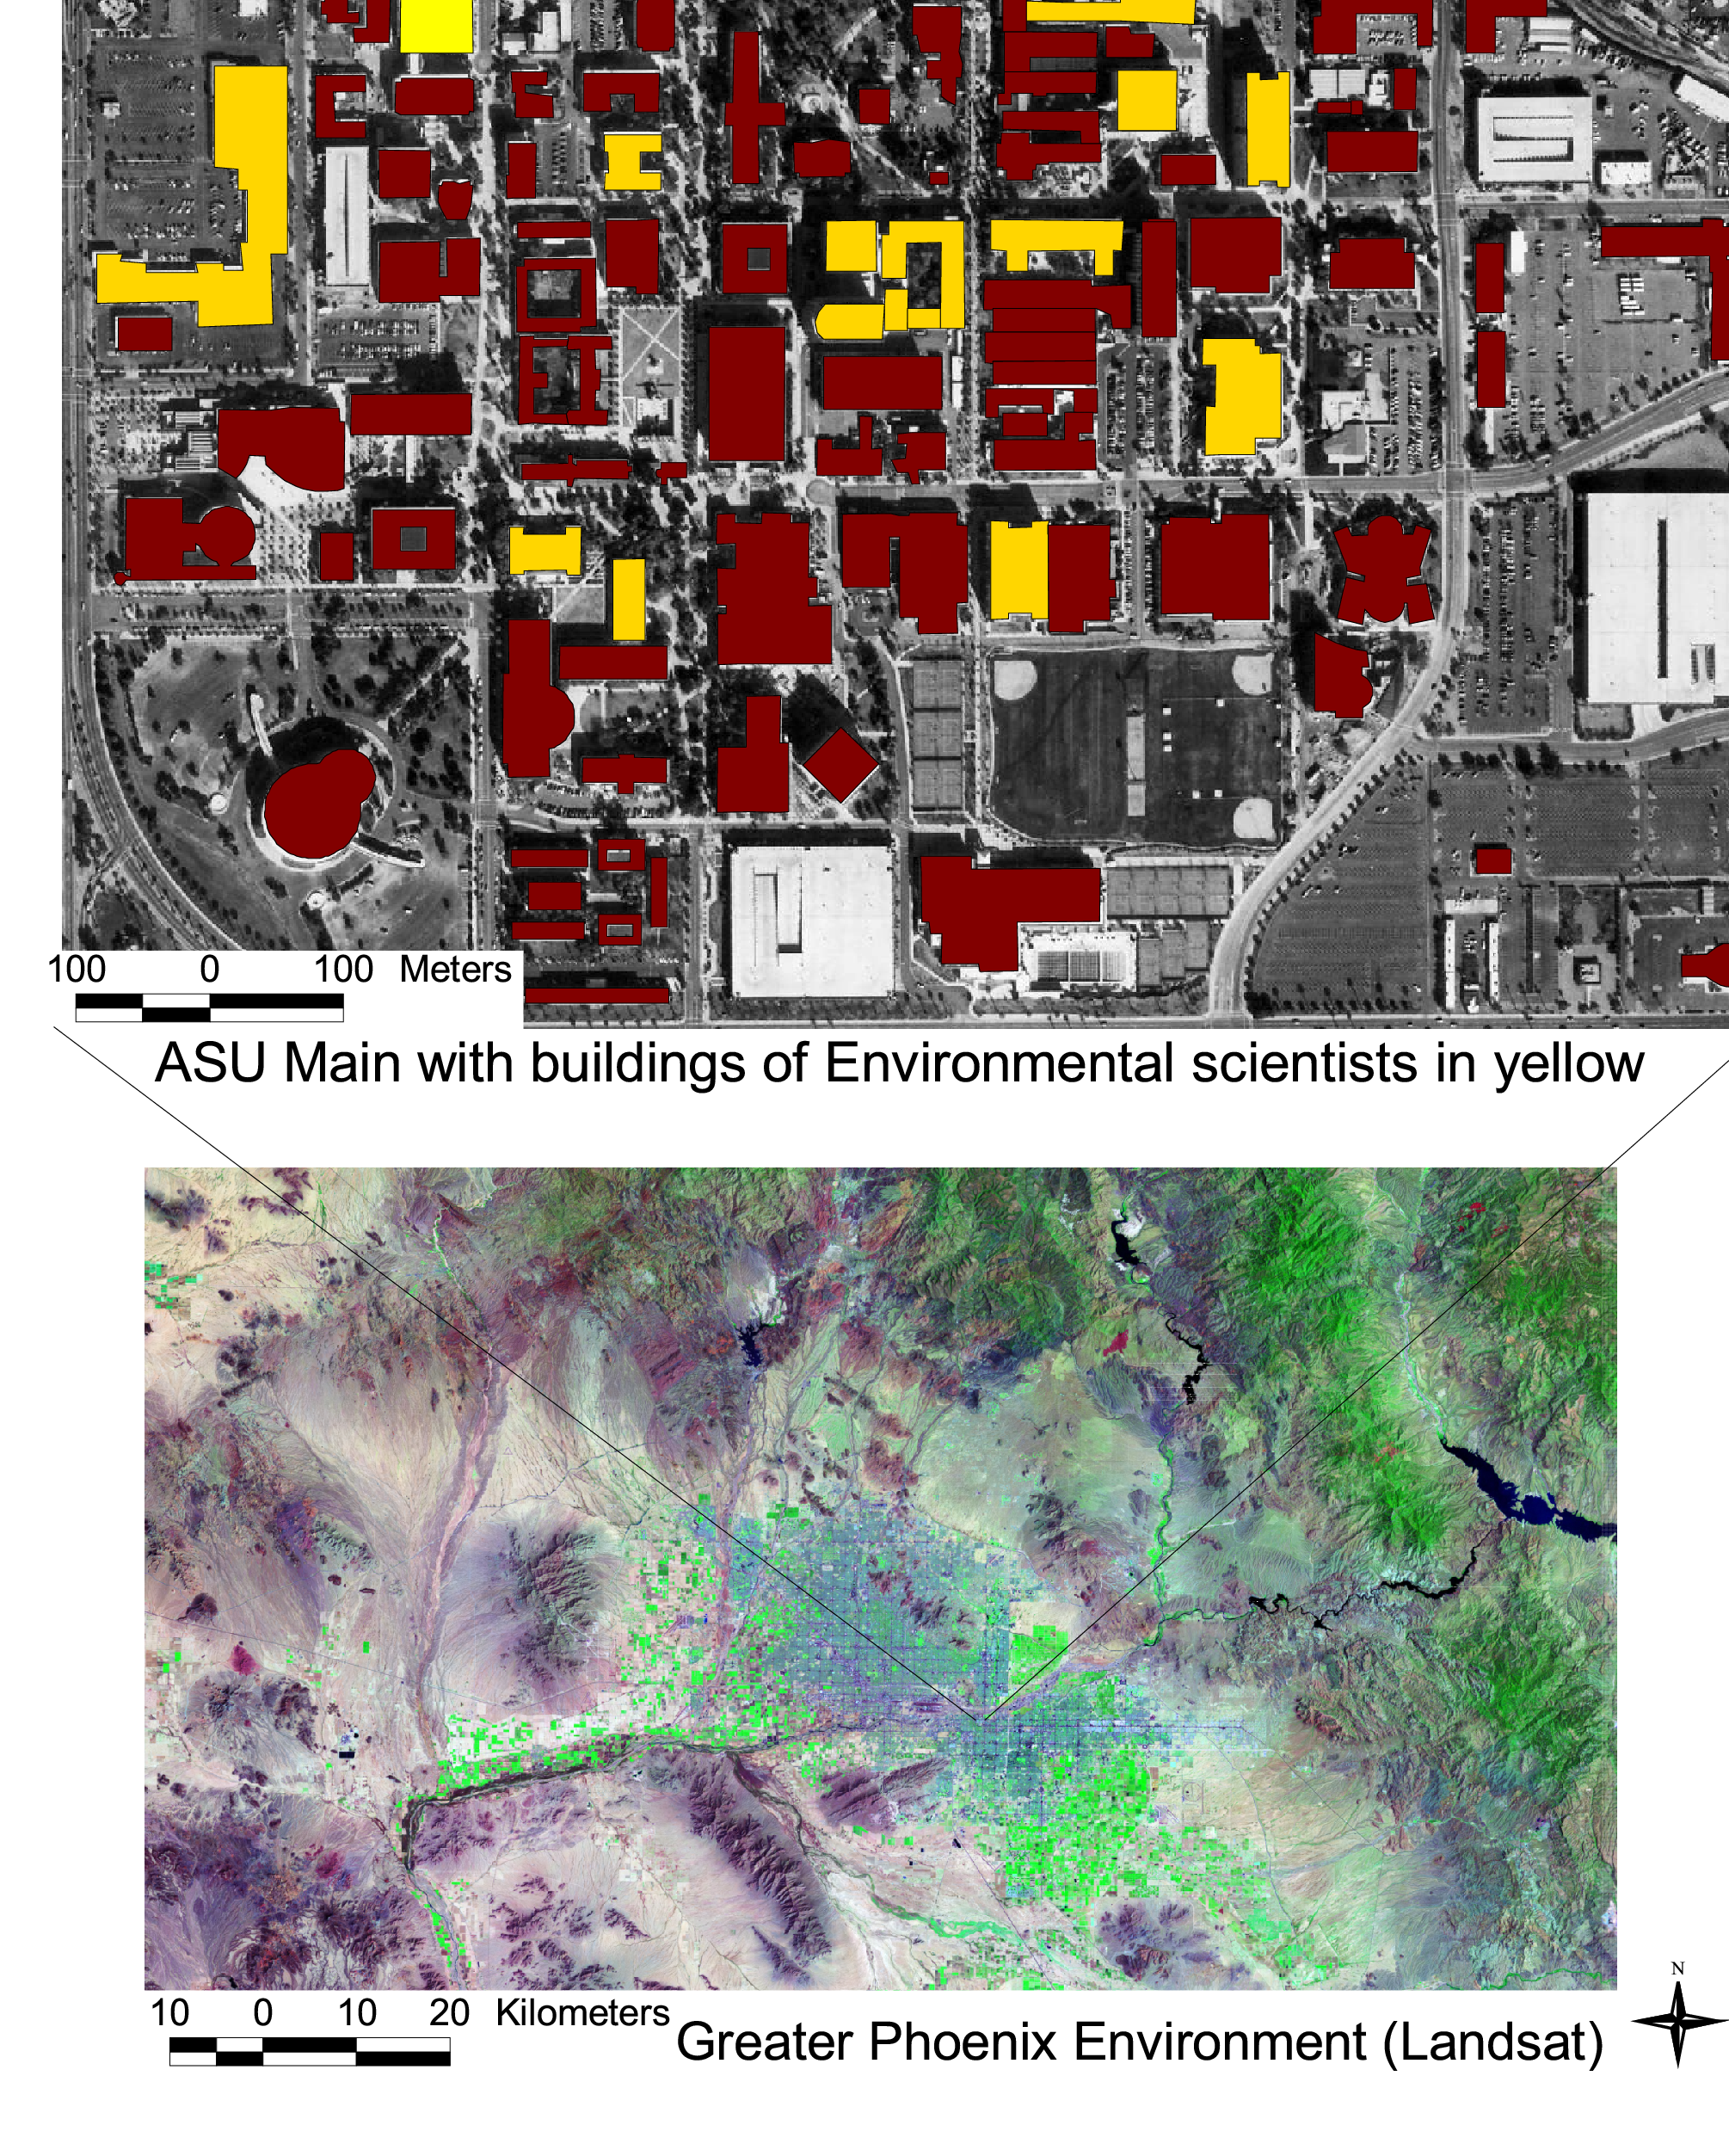
Introduction
Measures and models of the environment are located in space (3 dimensional). We are often interested in their depiction of change and thus when we include time, they become 4 dimensional. These data and models are also highly variable in type, quality, quantity, density, and reference frame. We may have relatively uninterpreted synoptic data (such as satellite imagery or topography), focused measurements of parameters (traffic speed), or highly interpreted discipline-specific data (i.e., geologic map). Furthermore, these data and models are often generated and maintained by diverse groups, ranging from government agencies (i.e., Arizona Department of Environmental Quality) to archival anecdotal information in libraries to academic researchers’ projects.
Progress in our understanding of the interaction between humans and their environment is critical and it requires the synthesis of these disparate datasets and models. Using the tools of information technology applied to the collection, compilation, vetting, merging, analysis, and visualization of these data, we can attack significant problems of wide interest to the ASU academic community as well as the broader Arizona populace. The demographic cauldron of Phoenix provides a unique opportunity to chronicle how rapid urbanization impacts the economy, ecology, and social fabric of a modern metropolitan area. But how can one characterize such a complex system in a meaningful way? What sorts of data can be used to document the roots of the current explosion, the path it is taking, and the likely outcomes? How can the lessons uncovered by scientists and engineers be translated into forms that can help political leaders craft public policy? And finally, what role can information technology play in unraveling this seemingly chaotic jumble of forces? Numerous research groups on the ASU campus are addressing aspects of these questions; however, Information Technology has not yet been brought to bear in a coherent way amongst them on the research at hand.
We propose to integrate analysis of environmental data and models across Arizona State University. The environment is broadly defined and the focus is the greater Phoenix region with obvious applicability to burgeoning urban growth worldwide. We will bring together the diverse datasets and models into common spatial and temporal frameworks, develop and utilize tools to manage and measure their quality, and apply methods of data mining and knowledge discovery and visualization to learn from them to improve the quality of environmental understanding and enhance decision making in the region. For the greater Phoenix region to be economically competitive and viable, we can work from a position of strength through integrated environmental knowledge.

Mission
“The Center for Integrating Analysis of Environmental Data and Models brings information technology tools to the fusion, overlay, mining, and modeling of environmental characteristics, history, and simulations for the future. A broad group of ASU researchers and local and regional agencies come together to solve common geospatial and geotemporal problems. For the greater Phoenix region to be economically competitive, it must come from a position of strength through integrated environmental knowledge. “

Environmental and urban research at Arizona State University
Greater Phoenix is an ideal laboratory in which to build integrated environmental knowledge, and Arizona State University (ASU) is uniquely positioned to carry it out. ASU has made urban environmental research a central portion of its strategic agenda, both for the richness and diversity of the scientific questions it contains, and for the opportunity it provides the University to serve its community. Examples of ongoing projects addressing these issues include one of only two NSF-funded urban Long-Term Ecological Research (LTER) grants (http://caplter.asu.edu/; a team effort with 47 co-investigators from 14 ASU departments); an Interdisciplinary Graduate Education and Training (IGERT) program in urban ecology (http://www.asu.edu/ces/igert.htm); major NSF grants to study the “urban CO₂ dome” and processes of urban fluid dynamics (http://www.eas.asu.edu/~pefdhome/); a NASA study that monitors growth of 100 desert cities using remote sensing (http://elwood.la.asu.edu/grsl/UEM/); and close partnerships with a multitude of state and local agencies. In addition, at least 18 departments and schools across the university research and teach in these subjects and develop tools for their analysis (http://www.asu.edu/gislab/asugis/people.html).
Despite this strong foundation, each component produces a torrent of non-communicating, dynamic datasets that race by too quickly to be effectively integrated or even comprehended. Many projects and group are isolated and some efforts are duplicated. In this Center, we will literally integrate the groups by providing direct research staff support for a number of promising growth areas and indirect community--building via seminars, visiting fellows, and student support. It will figuratively integrate and build the urban environmental research and teaching agenda.

Plan for research enhancement
Research and Information technology components are interwoven but may be defined as an environmental system comprising Anthrosphere, Atmosphere, Hydrosphere, and Geosphere. Each is spatially defined and changes with time. We will strive to find a balance between division of groups for organization and integration of groups for knowledge building. In the table below, we outline the research projects that we have identified to have particular promise for development into fundable and regionally significant projects with Center support.

Environmental Research Projects | Possible 1st year support
The Greater Phoenix 2100 project (http://www.gp2100.org), initiated by Arizona State University, is a n effort to make the best possible scientific and technical information useful for knowledge-based decisions that will shape the region during the next 100 years. | 50% post doc
Mining and delineation of trends and inter-relationships between variables from large data bases obtained through LTER and EFD's atmospheric simulations efforts | 50% post doc
Climate database: The Department of Geography/Office of Climatology is currently setting up a database to archive the Arizona Flood Warning System (AFWS) real-time data. The real-time data will be used to initialize and update real-time mesoscale circulation prediction models with a high spatial and temporal resolution dataset. | 50% post doc
Location research: How can high quality environmental data improve the business climate for the greater Phoenix area? | 50% post doc
Urban structure and growth | 1 RA
Urban monitoring: remote sensing and the wired environmental laboratory; high resolution depictions of natural processes and urban responses: implications for real time monitoring of urban/natural systems | 1.5 RAs
Building a common platform among environmental models | 1 RA
Large spatial scale correlations between urban and natural patterns | 1 RA

Information Technology and Information Management tools and research
Our major efforts will be to establish standards, query structure, metadata for both data and models, and the virtual and operational relationships among the data producers, modelers, and users. We will identify and coordinate datasets and modeling tools – some from state agencies, others from across disciplines that address environmental data that interact to affect air quality, for example. The goal is to provide a powerful tool for analysis, and build partnerships to demonstrate the practical value of science in the political process. The sections below describe the major tasks.

Coordination of diverse data/model content, types, formats and procedures
We wish to improve the interaction between scientists and decision makers by providing simplified access to modeling and visualization tools to help them analyze complex relationships among data and envision different scenarios. A key initiative of the Governor of Arizona and state technology planners is to create a single entry point for electronic access to state data and services. We will build on the current role and reputation of ASU and its Visualization, GIS, and environmental planning support for state agencies. We will leverage the powerful interdisciplinary research teams and environment that have emerged at ASU in recent years to develop the necessary standards and cooperative agreements to prove concepts and lay the groundwork for expansion. By focusing on the standards and coordination rather than a fixed central database, we will more effectively leverage project funding to create partnerships between scientists at ASU and state agencies and educators that will have significant impact far beyond the original project.

Creation of an integrated structure to define and acquire data in response to queries
We will use these agency and university sources to identify the varied data sets and modeling tools involved, produce a data description and organization schema and XML structure for access, develop programming to overlay displays, and provide interactive linkages among key visualization and modeling applications. The project team will work with emerging GML (geographical markup language) data definitions to describe content features and elements, and develop style sheets for display incorporating elements from multiple data sources. Web mapping specifications (WMS) will support merging data from multiple sources in a relatively small .gif. or .jpg file format that supports web based display. Open locator services (OpenLS) will also be explored to dynamically link and display data from location-aware applications and devices.

Creation of a query interface to search, display, interact with, and analyze databases and models.
Creation of a simple web accessible user interface, the capacity to post analytic and interpretive data for other users, and the ability to access and re-evaluate the original data will create a valuable, accessible, interactive resource. This functionality has the potential to dramatically increase the range of users and potential impact on education training and decision-making. A model using this approach has been developed for anthropologic pottery data and is incorporating datasets and models from other disciplines (Rowe is CoPI; KDI: 3D Knowledge: Acquisition Representation & Analysis in a Distributed Environment; http://3dk.asu.edu).

Guidelines for data acquisition, database population, file formats, & metadata over time
Standards and descriptive schema will be developed as a bridge for access to multiple databases. Standards for data description, file formats, and cataloging will simplify coordination among agency and research participants. We will create a framework for monitoring both the interaction of people and the environment, and of access to the data across disciplines and to planners and decision makers. Given the rapid changes in the region, we will document change during the life of the initial project. Our goal is to create a process that will continue beyond the life of the grant to provide access to data and evaluate changes and quality of decision making over time.

Plan for integration and curriculum enhancement
An important role for the Center will be to catalyze on and off campus collaborations for student training and recruiting, project development, and research area focusing. These will be accomplished with:
- Curriculum development in which courses and seminars will be proposed and developed by ASU faculty with potential off campus collaborators.
- A visiting scholars program in which we will invite colleagues to campus for a month or so to interact with students and researchers and develop viable research proposals. We could invite researchers and thinkers to campus who might have some interest in or advice for us in our efforts. These connections might help us to get to know what else is going on as well as to establish ties that would be strategic for future fundraising or intellectual development efforts.
- Additionally, we will invite colleagues to campus for shorter time periods (a couple of days as part of a seminar series open to all where we can explore the Information Technology and interdisciplinary issues that are our focus.
- Student travel awards will be available to current students to visit laboratories for advanced training and collaboration. We will also use these funds as recruiting tools to bring in excellent students early (summer before admission to ASU) and get them hooked on our program.
- Outreach to decisionmakers in the state at which we could have an “Environmental Information Summit” where we could give them views of our data and models and possibly interactively enhance decisionmaking. In addition, they could give us some feedback on what could be useful data/models/projects on which we might focus. This will emphasize hands-on collaborative workshop format, rather than lectures in a big room with passive listeners.

Outreach
A significant initial effort to establish common vocabulary, descriptions, and intellectual strategies will enable smoothly functioning cross-disciplinary project teams. A second phase will address interaction between the project team and city-county-state-federal entities. Once the tools and interface have been developed, outreach activities will involve training and expanded use by state agencies in addition to traditional academic outreach through conference presentations and publications. We will also join with established outreach efforts (Arizona Geographic Alliance and Ecology Explorers; see below). The web-accessible modeling and visualization tools will support access by high school, community college, and university science and government users. Beginning in year 2, we will introduce an interested group of high school, community college, and university faculty to environmental modeling and visualization for their curriculum.
Arizona Geographic Alliance. The environmental data and models articulate with several K-12 educational standards in the state of Arizona, most notably those in Geography (see http://alliance.la.asu.edu/azga/; a network of more than 2700 teachers). We will facilitate K-12 students’ learning about urban growth issues while they participate in the research process. Teacher training through a series of weekend workshops will enhance the ability of instructors to convey how the scientific method works.
Ecology Explorers. This program (http://caplter.asu.edu/explorers/) gives Phoenix area K-12 students and teachers opportunities to do scientific research with the CAP LTER project. Students use the data they have collected to look for patterns in their own research sites (schoolyard or backyard), and the data can be shared with other researchers and school children to see what patterns in nature exist across the entire Phoenix area.

University—government agency and industrial liason building
One of the jobs of the post docs and research assistants in this project will be to go to various local corporate headquarters and government agencies trying to make contacts and build collaborations. They will carry with them specific examples of the kinds of work performed at the center and the questions it could address -tailored to the corporation or agency being visited. For example, if they talk to the hazard insurance industrial colleagues, they should take some examples of flood or lightning or heart attack risk maps, with information about what data go into such a map, and perhaps questions about what other types of data need to be included. These “environmental information ambassadors” will work to elevate ASU’s environmental research profile and seek to establish concrete ties. It seems clear that not only is much environmental research done on the ASU campus in (semi) isolation, but also it is done independently in government agencies and industry. ASU can become known as the environmental knowledge broker and bring data and models together and show how these parties can find advantages with such enhanced views of the greater Phoenix area. This would culminate each year in the Environmental Information Summit described above.

Evaluation and Assessment
This project provides a valuable opportunity to evaluate and assess the interaction between researchers and business, government, educational, and public users. Formative evaluation will guide the development of collaborative models, standards, and project design decisions. Interfaces and tools for multi-disciplinary data analysis will be evaluated in terms of effectiveness within the project design team. Training and educational components for external users will be evaluated and revised during the course of the project. Summative evaluation will be used to determine progress of the completion of key project elements.
Acting in an advisory and review mode, prominent public officials, scientists, and interested citizens will work with the management team in the form of a Multi dimensional planning advisory council. The council will provide focus, database evaluation, scenario generation, and project promotion to the greater Phoenix community and beyond. Potential members include many of the most prominent community and business leaders in the region. Additional guidance will come from regular consultation with engineers and principals of Environmental Systems Research Institute, Inc, (ESRI)—the producers of the industry standard GIS—ArcInfo.

Collaboration with the Urban Security Team at Los Alamos National Laboratory
Integrated modeling and analysis of urban systems are the expertise of Los Alamos National Laboratory (LANL) Urban Security Team colleagues. This group has been successful at simulating realistic urban security scenarios such as an Airborne Toxic Release/Emergency Response (http://www.lanl.gov/orgs/tsa/tsa4/aquality/urban.html). Our LANL collaborators will focus their efforts on modeling and scenario generation. The integrative training aspect of this project will be collaborative and sustained interaction via graduate student and post doc work with the LANL team. They have had much success with students spending extended periods at LANL in the rich, creative, and technical environment where coding, algorithms, and scenarios can be developed and tested, and then brought back to ASU and implemented in the various research projects, as well as applied to the urban security research problems at LANL.

Relevant high profile initiatives
Understanding the interaction between natural and urban processes has importance in basic research areas of urban ecology, urban structure and growth, urban geomorphology, urban monitoring, environmental fluid dynamics, knowledge systems, information management, data fusion/mining, and visualization. It may be more important locally in applied aspects such as decision support, Digital Government, and air quality management. These research areas have been identified in various ways in calls for proposals and white papers outlining major initiatives. This Center positions us to develop a number of proposals for submission to the following targets:

Federal

Environmental Protection Agency
The Livability program of the EPA (www.epa.gov/livability/) focuses on understanding sprawl and working with municipalities on smart growth. The environmental knowledge we will develop will help us to understand our own sprawl. With EPA support, we could work as a knowledge broker with the various agencies of the state, counties, and cities to evaluate smart growth plans.

Homeland Security
A massive infusion of Federal resources into the Federal budget reflects the priority the President has attached to the homeland security agenda (http://www.whitehouse.gov/homeland/). Security is a spatial and temporal problem and maintaining it requires high quality data and models to inventory and simulate threats and responses. Many federal agencies are retargeting their foci to homeland security. We can develop the integrated environmental information systems to increase security.

National Science Foundation

Collaborative Large-scale Engineering Assessment Network for Environmental Research (CLEANER; NSF Engineering)
This proposed NSF program is a perfect match for projects discussed above such as GP2100. It comprises 4 main aspects: a network of regions such as greater Phoenix instrumented for the acquisition and analysis of environmental data; a virtual repository of data and information technology for engineering modeling, analysis and visualization of data; multidisciplinary research and education infrastructure focusing on the networked instrumented sites; and formulation of engineering and policy options directed toward the protection, remediation, and restoration of stressed environments and sustainability of environmental resources (Luthy, 2001).

Information Technology Research
Congress and the President have recognized the need to advance fundamental and applied research in Information Technology. This has translated into significantly increased funding levels: the 2002 request is nearly triple that for 2000. Portions of the research program in this proposal was developed for an unsuccessful proposal to the NSF-ITR medium grants program (<$5M total; Arrowsmith, et al., 2001). This Center will help us to develop a similar and more competitive proposal.

Digital Government
“The Digital Government Program funds research at the intersection of computer information sciences and government information services, with the goal of bringing advanced information technology to the government information community.” (http://www.diggov.org/mission/). This Center will promote the development of the information technology tools and university—governmental collaborations to achieve these goals in the greater Phoenix region.

Integrative Graduate Education and Research Traineeship (IGERT)
ASU has two IGERTs currently: Urban Ecology (http://www.asu.edu/ces/igert.htm) and Neural and Musculoskeletal Adaptations in Form and Function (http://www.eas.asu.edu/~igert/). More are in development and ASU is gaining a good reputation at NSF as a place that “…knows how do run these things.” We might develop an IGERT in integrated environmental analysis and modeling and contribute to one in Biogeochemistry. At the very least, we can tie in to the active research environment of the existing Urban Ecology IGERT.

Arizona
The Arizona Geographic Information Council (AGIC; http://www.land.state.az.us/agic/agichome.html) is working on a state-government network to permit agencies to more freely and easily pass data back and forth via several different hardware/software/network avenues and to provide agencies without any spatial capabilities a 'canned' application that gives them access to basic spatial data. possible role for ASU in this scheme is to serve as a quality data broker. This plan will be coordinated with the Government Information Technology Agency (GITA; http://gita.state.az.us/) and others to increase "buy-in" for easier, faster, more efficient sharing of information. This effort will move beyond State government, out to local and regional government entities as well.

Discipline-specific
Many research groups already have urban environmental research projects going and the technical and knowledge infrastructure coming from this intitiative will clearly advance discipline-specific research.

Management plan

Management
The Center will be managed by an interdisciplinary executive committee with a director and consisting of Arrowsmith, Hutchins, Mussachio, Rowe, and Wentz. This group will oversee the progress of various research components.

Facilities
Approximately 50% of the center’s staff (including visitors) will be housed within the expanding GIS lab in the Computing Commons (CC235; the Visualization Lab is being decommissioned and so they are in the early stages of reconfiguring this room - replete with high speed connections, reconfigured layout, and video-teleconference capabilities). This is still to be negotiated, but it would provide an excellent space in which research would be performed and leverage the efforts of the already busy GIS laboratory. Several new computers and a server will be purchased to support Center projects. Certain projects will be better performed if the staff are part of existing groups and thus we anticipate the other half of the center’s staff will be dispersed. Weekly project and center meetings and some seminars will take place in the Center facility.

Budget
Here is a schematic budget that includes modest faculty support for summer research/management and curriculum development efforts, for two Post-Docs to help guide and enhance the impact of the work, a bit of technical support, and the main effort: graduate research assistants. In addition, the integrative efforts described above are largely manifest as travel funds in the budget. We will require computing tools to proceed. The target funding level is starting at $255k and ramps down over the next two years to emphasize the importance of raising external funds to keep the Center going.
Center for Integrated Analysis of Environmental Data and Models
 |  |  |  |  | 7/1/02-6/31/03 | 7/1/03-6/31/04 | 7/1/03-6/31/05 | 7/1/03-6/31/08
 |  |  |  |  | Year 1 | Year 2 | Year 3 | TOTALS
Salaries
PI Summer support |  |  |  |  | $15,000 | $10,000 | $6,667 | $31,667
Curriculum development support |  |  |  |  | $7,000 | $7,000 | $7,000 | $21,000
Post Doctoral Scholars |  |  | 2 | 100% calendar year @$35k/yr | $70,000 | $46,667 | $31,111 | $147,778
Computer/technical support |  |  | 0.1 | 100% calendar year @$55k/yr | $5,500 | $3,667 | $2,444 | $11,611
Graduate student RA 50% academic year + 66% summer
 | # yr 1 | # yr 2 | # yr 3 | $20,000 | $90,000 | $60,000 | $20,000 | $170,000
 | 4.5 | 3 | 1
Fringe |  |  |  |  | $31,900 | $21,267 | $12,178 | $65,344
Total salaries |  |  |  |  | $219,400 | $148,600 | $79,400 | $447,400
Permanent equipment
GIS workstations (Win2000 P4) and lab set up |  |  |  |  | $15,000 | $0 | $0 | $15,000
Travel
Visting Fellows |  |  |  |  | $10,000 | $10,000 | $10,000 | $30,000
Seminar series |  |  |  |  | $2,000 | $2,000 | $2,000 | $6,000
Student travel |  |  |  |  | $2,000 | $2,000 | $2,000 | $6,000
Total Travel |  |  |  |  | $14,000 | $14,000 | $14,000 | $42,000
Other
Software licensing |  |  |  |  | $500 | $333 | $222 | $1,056
Computer and lab supplies |  |  |  |  | $1,000 | $667 | $444 | $2,111
Environmental Information summit |  |  |  |  | $5,000 | $5,000 | $5,000 | $15,000
Total Other |  |  |  |  | $6,500 | $6,000 | $5,667 | $18,167
Total |  |  |  |  | $254,900 | $168,600 | $99,067 | $522,567
Targets: |  |  |  |  | $240,000 | $160,000 | $80,000

References
Arrowsmith, J R., Rowe, J., Steiner, F., ITR/IM: Tracking the untrackable: Using information technology to chronicle the skyrocketing urban growth of Greater Phoenix, Arizona from 1900 to 2100, NSF-ITR proposal, 2001.
Luthy, R. G., Collaborative Large-scale Engineering Assessment
Network for Environmental Research: CLEANER Workshop report, December 4-5 2001.

